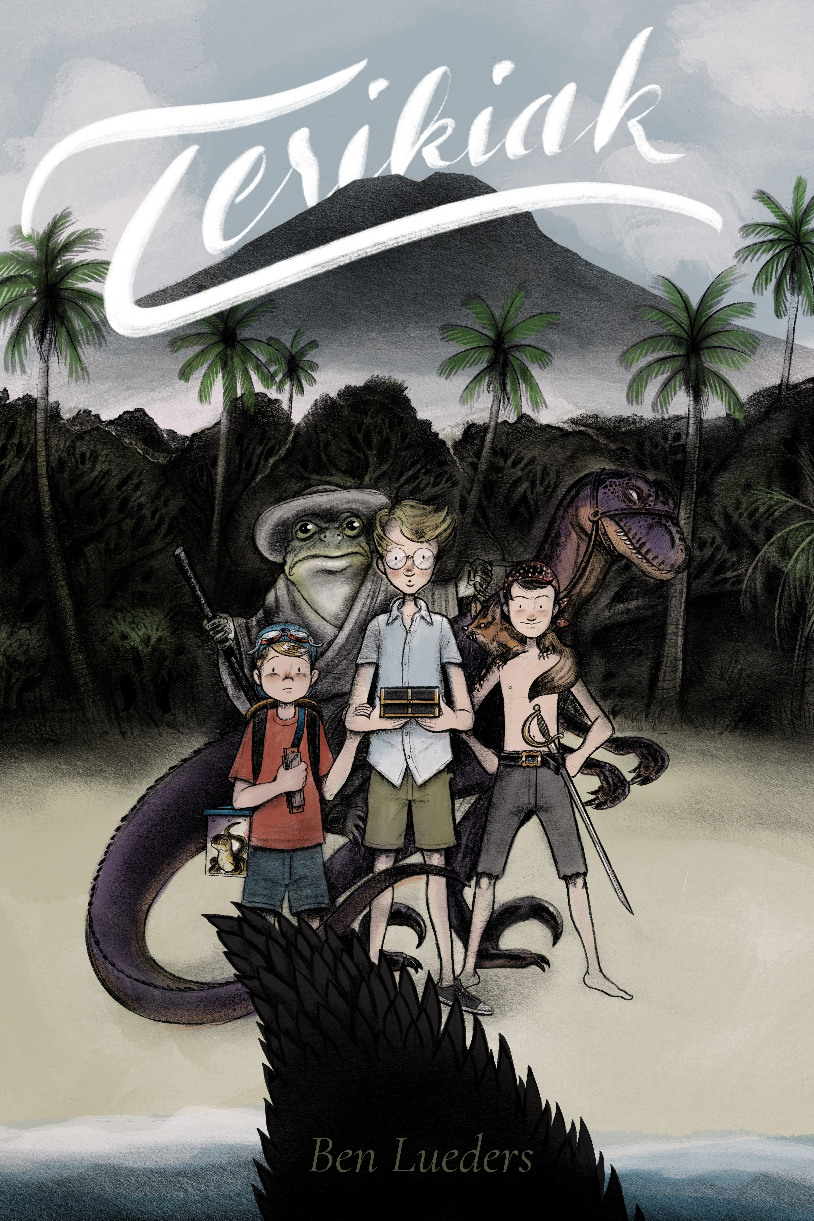

TERIKIAK
Ben Lueders

Copyright © 2022
All rights reserved.
Benjamin Abram Lueders
4954 Ohio St.
Omaha, NE 68104
(402)650-1547
ben@benlueders.com
www.benlueders.com
www.terikiak.com

To my three sons Jonah, Isaiah, and Gideon
whose unbridled imaginations and creativity
brought this story to life.
Chapter 1: The Son
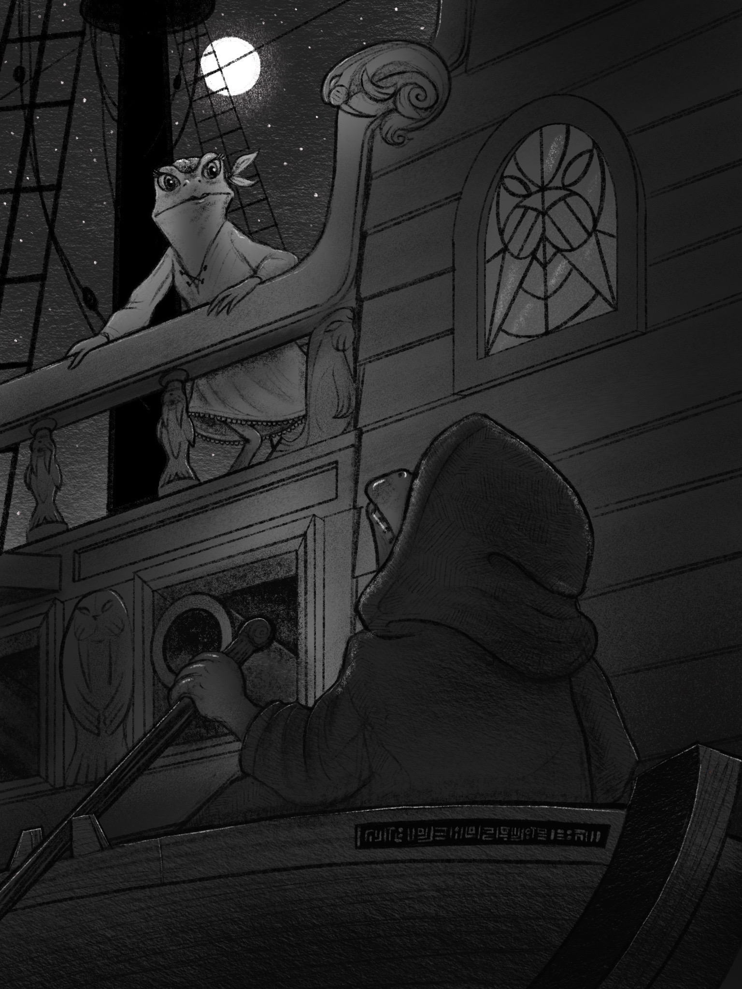

“H
old still. I’m coming with you.”
Santiago’s mother peered down at him from the bow of the great ship. Her green skin glistened in the starlight—a warm night wind rustled her white dress and the rowboat that her son now found himself in.
“Be careful mother—they might hear you!”
Santiago’s bright eyes were wide with fear, scanning the side of The Merrie Marauder for any signs of movement. “But first, take this.” Evangeline pulled something out of one of her deep dress pockets. “What’s that?” The young frog was mesmerized by the object in his mother’s hand: a golden box that glittered in the moonlight. “No time to explain now. Catch!” She tossed it gently to her son. The box was sharp and cold to the touch. Santiago knew they had been planning to escape, but didn’t realize they would be stealing something in the process. “Alright, here I come.” His mother balanced precariously on the side of the boat and began to crouch down for a jump.
“Evangeline!”
The deep voice of Broog rumbled from below deck and cut through the air. Evangeline almost lost her balance as she froze. Footsteps shook the ship as the voice drew nearer. “Jump, mother!” Santiago grabbed the oars, ready to push off. Evangeline’s face was turned away for a moment toward the sound of Broog lumbering closer. Suddenly her face shot back toward her son. Her eyes filled with sadness.
“Row westward, my son—row until you can no longer see these terrible, pink sails.”
With that, she cut the rope mooring the rowboat with a dagger, tossed it toward her son, and slipped away into the darkness of the sleeping ship.
Santiago wanted to scream. He wanted to jump back on the boat and grab his mother—but he knew that would not accomplish anything. Within moments, the entire ship of ruffians would be awake, and they’d be in an even worse predicament than when they started. His mother had told him to row and he would obey his mother.
As he gently pushed off with the oars, he could hear the kind voice of his mother talking to Broog, buying him precious time to slip away. His eyes filled with tears as he thought of the failure of his mission. He had finally come to set his mother free but instead he had become a captive himself, and his mother had just saved him. He glanced down at the mysterious, golden box at his feet. I didn’t want a stupid box. He thought. I wanted my mother!
Santiago sadly rowed westward—away from the ship—until he no longer could see The Merrie Marauder’s terrible pink sails.

Chapter 2: The Ficus Family
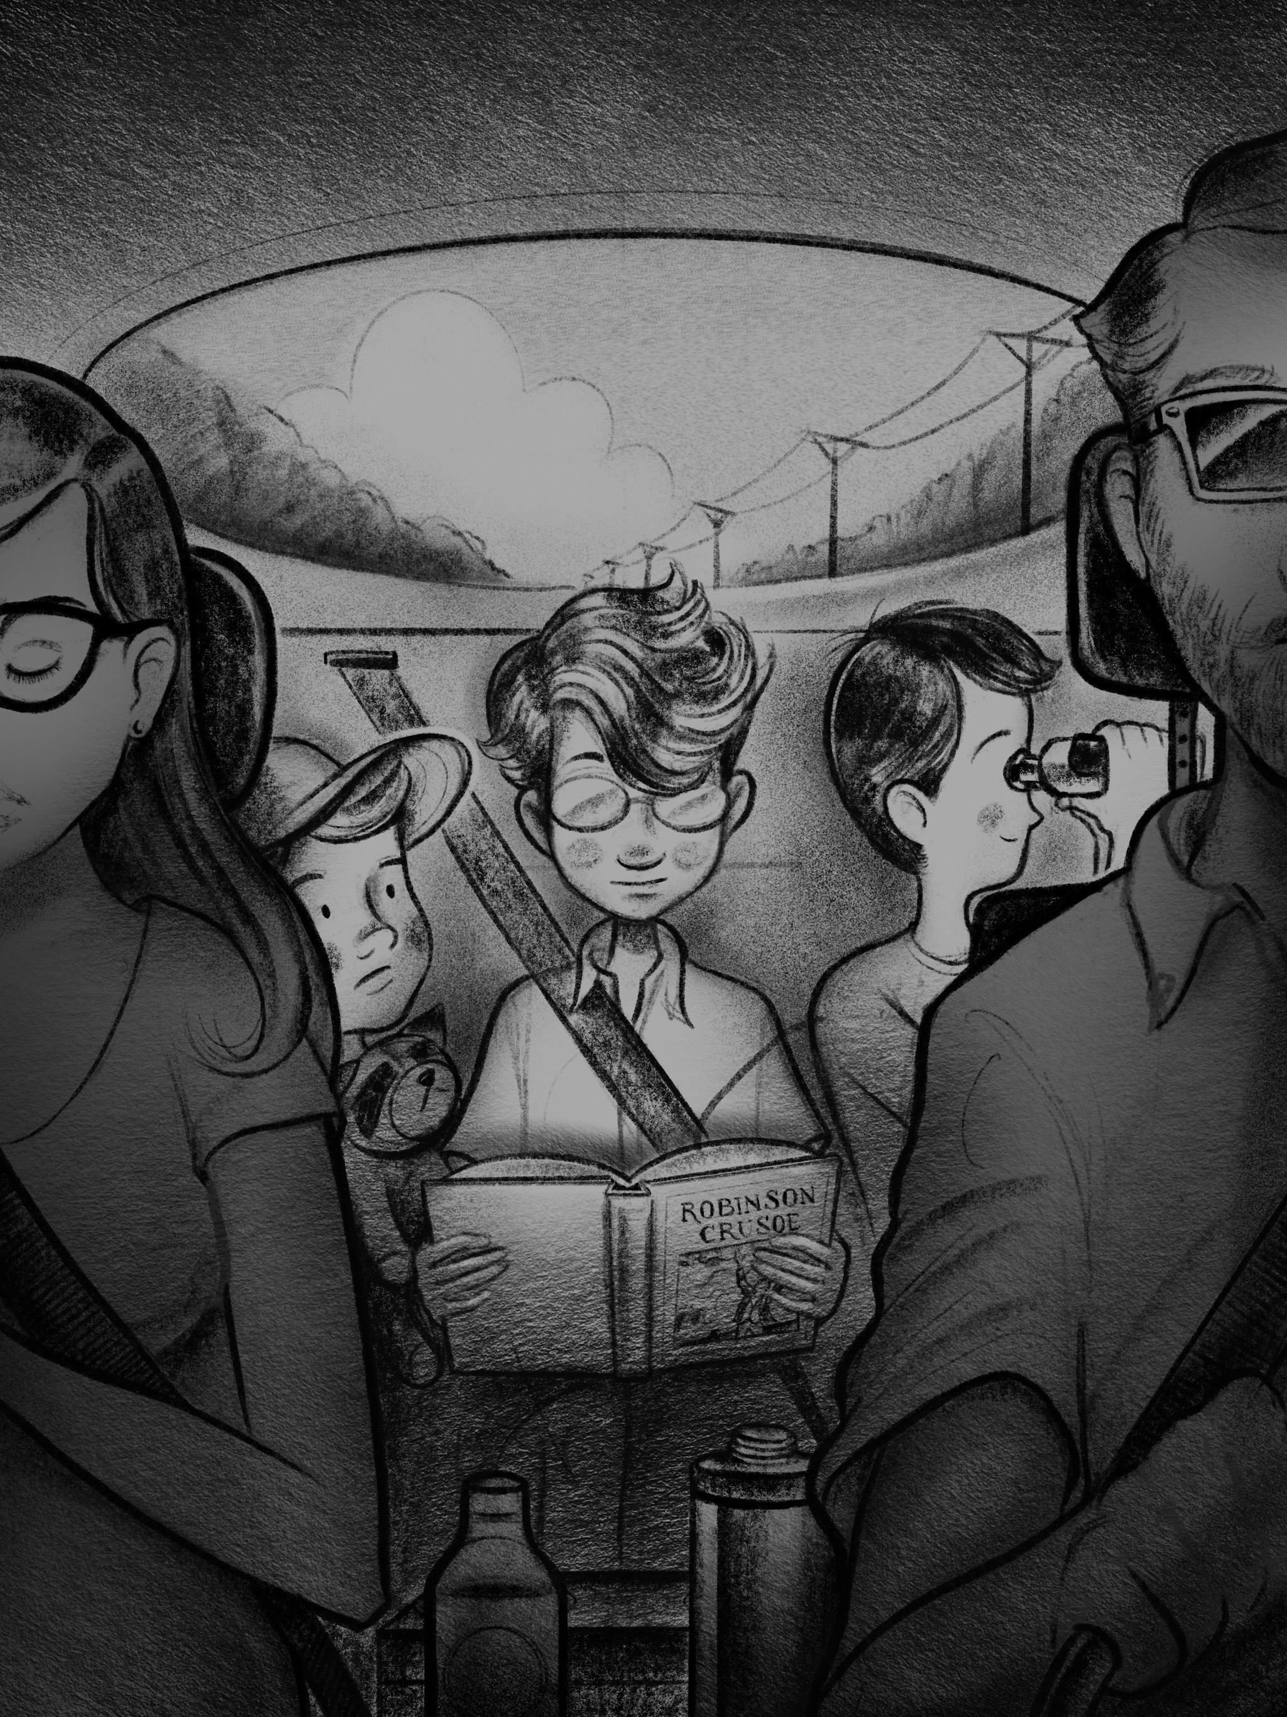

“I
think I can see it!”
Eight year old Alexander Ficus was peering through his trusty, green binoculars out of the speeding, gray, minivan window.
“It would be impossible for you to be able to see it already.”
Alexander’s ten year old brother Arthur rolled the blue eyes behind his round glasses. He didn’t even look up from his copy of Robinson Crusoe.
“If my calculations are correct, we are still approximately twenty-five miles away from our destination.”
Arthur said this in a way that definitely implied that his calculations, in fact, were correct. He pushed his wavy golden hair out of face as he continued to read.
“I still think I can see it.” Alexander mumbled under his breath defiantly—still peering out of the binoculars with his squinty dark eyes.
Arthur stopped reading and looked at his foolish younger brother. He wasn’t about to let this go.
“Zander,” he addressed Alexander by his family nickname, “we left that gas station at 3:45 and we still had approximately 105 miles left to go.”
Arthur glanced at his dad in the driver’s seat.
“Dad has been consistently going seventy-five miles per hour, which is fifteen miles per hour over the speed limit. At that rate, we should arrive at Slaughter Beach at 5:15. It’s 4:45 now, which gives us another half hour before we would be able to see the beach, let alone actually be able to see our cottage. So—trust me—you don’t see it.”
Alexander sighed.
“Whatever. I still think I can see the beach anyways.”
Arthur rolled his eyes again.
Suddenly, the minivan went quiet. Their third and youngest brother, Gus, stopped blowing on his dad’s shiny, Marine Band harmonica for a second.
“What do you see, Zander?” he asked with a slight speech impediment, that made Zander sound like Zandew.
Five year old Gus was wearing a bright red ball cap with a pair of clear, blue swimming goggles strapped to the top. Gus was a sweet boy that loved to entertain and make his brothers and parents smile. But even with his constant harmonica playing, singing silly songs, and telling funny stories, Gus’ big brothers always found a way to forget about their little brother. His real name was Augustine, but everyone just called him Gus.
“He sees nothing, Gus!” Arthur barked.
“Shut up!” Alexander smacked his smarty-pants big brother in the face as Arthur ripped the binoculars out of his brother’s hand. Feeling left out of the fun, Gus reluctantly smacked Arthur on the head with his harmonica, and then began blowing on it incessantly, to add to the drama and tension.
“Hey! What’s going on back there?”
Their father Abram's dark sunglasses glared through the rear-view mirror before them. His bearded face was clearly scowling. He had been trying to enjoy a pleasant, adult conversation with their mother, Margaret, but was now trying to avoid using all of the cliché road trip phrases his own father used say during situations like this. Phrases like: Do I need to pull this car over? Or, Don’t make me come back there!
“Alexander hit me!” Arthur yelled, adjusting his specs that had become askew during the scuffle.
“Well, Arthur took my binoculars!”
Gus had started wailing on the harmonica again. This proved too much for his father.
“Gus! Would you stop playing that silly thing?”
The van got very quiet now. Abram was not so proud of his words this time—and neither was his wife.
“Honey!” She whispered sharply, moving her hand from her round, seven-month-pregnant belly to her husband’s leg.
Abram let out a defeated sigh.
“Sorry Gus.”
The father tried looking at his sad little son in the rear-view mirror as he drove.
“You sound great, buddy. I love that you’re learning the harmonica. It’s just…dad’s trying to talk right now. Ok?”
“Ok.”
Gus sounded like he was on the verge of tears. His uncle Tim had started teaching him how to play the harmonica a few months earlier—and now he could play Mary had a Little Lamb, Old MacDonald, and the less popular tune, Harmonica Veronica. He was so proud of having something special that only he knew how to do.
Abram had to put a bow on this situation.
“Arthur. Give your brother back his binoculars. Guys, we’re gonna be there in, like, five minutes. I promise! Just hold your horses.”
“More like thirty-five minutes.”
Now Arthur was the one mumbling as he threw the binoculars at his brother’s feet.
“What was that?”
Arthur’s dad strained to peer at his son over his shoulder while he drove.
“Nothing.” Arthur mumbled again.
Dad turned back to mom in the front seat.
“I don’t get it. I would have died to go on a vacation like this when I was a kid!”
Margaret moved her hand from her husband’s leg back to her baby bump as she replied.
“I thought you said you used to go on this exact vacation all the time when you were a kid?”
Abram paused.
“Well, yeah—and I almost died of excitement every time! Gosh, I swear these kids could ruin a trip to Disneyland!”
“I wanna go to Disneyland!”
Whined Gus, now looking forlornly out the window.
The dad shook his head, “You’d probably hate it!”

True to Arthur’s prediction, thirty-five minutes later they saw the sign:
Welcome to Slaughter Beach.
The grayish-blue hue of the ocean stretched off into the distance—just beyond grassy fields, rolling hills, and seaside cottages.
“Slaughter Beach. What a cool name!” said Alexander. His signature, creepy, toothy smile coming over his face. “I bet someone got slaughtered to death here!”
“Actually,” Arthur predictably corrected “it was named after a guy named William Slaughter in the 1700s.”
“Dang it, Arthur! You ruin everything.” Alexander scowled disappointingly.
“Boys!” Their dad must have been oblivious to their conversation in the back seat. “Wanna know why they call it Slaughter Beach?”
“I already do.” Arthur whispered, rolling his eyes and continuing to read.
“It’s because of the horseshoe crabs! This time of year, the beach is covered with them, and they die by the thousands. We used to grab the dead ones by the tails and throw them into the water when we were kids!”
“Cool!” Alexander’s creepy face returned. “I wanna cut them open and pull out their guts!”
Arthur simply stared at his younger brother.
Gus was still staring out the window. “Slaughter…otter…water...” He loved to make little rhymes.
“Gus—honey—that’s creepy! Don’t say things like that!” His mother corrected him from the front seat. “See what you started, dear?” She jabbed her husband with her elbow.
Distracted, Abram could see something approaching on the horizon.
“Look boys! There she is! The Slaughter House!”

Chapter 3: The Slaughter House
A
lmost every summer of his childhood, Abram Ficus’ family made the long drive up the coast and spent a few weeks in The Slaughter House. Despite its somewhat terrifying name, the house was a place of great memories and adventure for Abram. Now, twenty-five years later—as he pulled up the long gravel driveway to the house, he was struck by how little seemed to have changed. Except, of course, its size.
“It looks small.” Margaret Ficus squinted through her dark brown frames up at the two-story, white, wooden structure.
“Oh, it’s way bigger on the inside! Kind of an optical illusion.”
Abram put the van in park and turned off the engine. The whole family stared at the small house in silence for a moment. Arthur was the first to break the silence.
“I don’t think we’re going to fit.”
“That thing’s dinky.” Chimed in Alexander.
“Dinky, pinky, winky.” Rhymed Gus, randomly.
“Ok, we are going to fit, guys! Believe me. Everyone take a chill pill, and let’s start bringing everything in.”
Abram opened his door and the rest of the family clambered out of the van.

The Slaughter House was small. It wasn’t an optical illusion. Abram even started realizing this fact as he walked up to the porch, but his pride kept him from admitting it publicly. The house was up on stilts, but not as tall as the stilts on some of the other coastal homes nearby. This was probably due to its being situated on top of a great hill. Abram began to fiddle with the combination on the door, and a few moments later they were inside.
“See? I told you it was bigger on the inside!”
Remarked Abram with his hands on his hips, scanning the room with a face beaming of nostalgia.
But he was wrong again—it was still pretty small.
“And she hasn’t changed a bit!”
He was right on that point, however. Aside from the electronic combination on the door, very little had changed. Even the appliances were the same ones that his family had used twenty-five years earlier—and some of them had been old even back then.
“Hopefully everything still works.” Margaret muttered setting down a bright, orange suitcase.
“I’m sure it all works.” Abram quipped.
The door opened up to a small living room area, filled with a few pieces of old furniture and nautically themed decorations. To the left was a small, metal, spiral staircase going up through a round hole in the ceiling. The living room led to a cramped kitchen/dining room area surrounded by windows that looked out to the sea. Those panes of bluish-gray expanse did the most to make the small cottage seem bigger than it was.
The boys threw down their backpacks and ran to the kitchen to look out the back windows. Alexander scurried up on to the counter and pressed his nose and hands to the glass.
“Zander! Be careful—if you break that you’re gonna cut yourself!” Margaret shouted as she and her husband walked into a hallway to their right. The hall divided The Slaughter House, basically in half—separating the living room/kitchen half from a couple bedrooms and a bathroom. The master bedroom overlooked the sea, while the other bedroom—featuring two sturdy, wooden bunk beds—overlooked the front porch and winding road.
Abram walked into the bunk room and pulled a metal chain hanging from a ceiling fan in the center of the room.
“Wow! I remember these old beds.” He said as he grabbed the railing of the closest one and shook it—testing if they were just as sturdy as he remembered. They were. The three boys, apparently done looking out the kitchen windows, clambered into their new bedroom and started staking out their territory. Alexander took the top bunk to the left, Gus took the bottom, and Arthur claimed the entire bunk bed to the right by throwing his backpack on the bottom bunk and his body on the top.
“My brothers and I carved little things into the headboard. Let me see...” He moved the pillow on Arthur’s top bunk, and smiled as he revealed a plethora of scribbly carvings—half words and half doodles.
“What’s that?” Arthur exclaimed as he pointed to a menacing looking creature covered in what appeared to be porcupine quills. His dad chuckled as he remembered. “When I was a kid, my dad said there were legends of these creepy, spike-covered sharks. Their spikes were supposed to be razor sharp and could scratch holes in the bottom of wooden ships. Your uncles and I thought that was hilarious! We made up this character named Spike. See? There’s his name!” Sure enough, there was some rough lettering underneath the drawing:
“SPIKE THE SPIKY SHARK”
Gus, now staring at the ancient etchings, was hanging from the rail. “Are those sharks real, dad?”
“Spiky-sharks? Ha! No, buddy. I think old ship captains just made them up to have a more interesting story to tell their kids when their boats would hit a rock or something.”
“Aw, man!” Alexander sighed disappointingly. “Why are all the coolest things always made up?”
Abram smiled. “Ok, I think we’ve had enough archeological excavation for one day. Why don’t you guys go outside and explore while your mother and I unpack?”
“Yeah!” The boys sang in unison as they sprung out of the bunk bed and scrambled toward the back door.

Behind The Slaughter House was, of course, the sea.
It was grayer, larger, and more mysterious than the boys could even have imagined. Only Arthur had ever even seen the ocean before, and even then, only as a baby. He had seen pictures of himself as a six-month old baby, wearing a fuzzy, brown hoodie and plaid shorts on an apparently cold and windy shore. His parents would annoyingly show him these pictures every time he complained that they never take him to the beach. The Ficus kids lived in a completely landlocked and desolate place, somewhere in the middle of the country. There were definitely no oceans where they were from. No mountains either. There was barely even a river to break up the bare fields and hills that sprawled as far as the eye could see. But now, here they were: staring into the magical wilderness of the Atlantic Ocean and their imaginations were set ablaze with excitement. Even the white, sandy cliff that led down to the shoreline seemed like an adventure unparalleled by anything they had ever experienced in their bleak, short lives. As they hurried down the soft, crumbly sand, they could hardly contain their excitement.
“The ocean!” Exclaimed Alexander as he tossed off his slip-on shoes and shot to the lead in their speedy descent to the shore. “I think I can see the other side!” Arthur, stumbling a bit, grabbed onto a tree root for support. “You most certainly can not see to the other side! The Atlantic Ocean is approximately 5,000 miles to the nearest shore from this point.” Which is, approximately, correct.
“Ocean...potion...motion...lotion...” Gus rhymed as he followed his older brothers down to the beach.
At the shoreline, Alexander suddenly halted. His final step produced a loud crunching sound . “Ow!” His eyes had been so transfixed by the misty horizon that he had overlooked something even more spectacular directly before him.
“Horseshoe crabs!” The children exclaimed together.
Their father had not exaggerated in his description. As far as their eyes could see, the beach was littered with large, round, brown shapes—with long sharp tails sticking out behind. Some were dead and lying on their backs. Some were cracked fragments, like the one Alexander stepped on. But many were still alive—their tails moving up and down as they scurried around slowly on the shore.
Forgetting about his hurt foot, Alexander grabbed the shell that he stepped on and hurled it into the ocean. Arthur was already looking over a live specimen and starting to examine it in detail.
“They look so…prehistoric!” He gently touched the shell as it glided along the sand. Alexander, now holding a stick that he found, kneeled next to Arthur—as Gus watch quizzically from behind. “Let’s flip it over!” He shouted. And before Arthur could respond, he had successfully flipped the huge crustacean onto its back. Dozens of interdependent, clicking legs writhed all around—its long, straight tail trying to flip itself upright.
“I don’t love horseshoe crabs.” Gus said as he stared bewilderingly at the creature. “Don’t do that!” Arthur said as he shoved Alexander over and grabbed his stick. He flipped the crab back on its many feet, and it proceeded to glide away over the beach.
The three brothers stood up in unison from their crouched positions and paused for a moment, taking in their surroundings. White cliffs of sand, crashing waves, the entire Atlantic Ocean, and a beach full of prehistoric crabs.
Arthur couldn’t hold it in.
“This is going to be the best vacation ever!”

Chapter 4: The Box
“This is the worst vacation ever!”
Arthur exclaimed loudly as he threw his body into the old leather couch in the front room of The Slaughter House. “I’m bored out of my mind.”
What a difference a week makes. Alexander chimed in.
“Yeah, there’s nothing to do.”
If there’s one thing that parents hate to hear—especially on a costly vacation—it’s that their kids have nothing to do. Parents can always find things to do at all times. Of course, many of these things would be considered boring to most kids. Their mother, apparently found seashells stimulating.
“Arthur, why don’t you guys go find some shells on the beach?” Margaret Ficus called from her seat at the kitchen table. “You haven’t been out there at all today!”
“I hate that stupid beach.” Arthur exclaimed.
“We‘ve already found every stupid shell on that stupid beach.” Added in Alexander who had joined Arthur in slouching miserably on the couch, looking as if the two of them were melting under an intense heat of boredom. Gus—who had been contentedly coloring a picture of a red panda on the floor—was starting to feel like he was being left out of some great complaining.
“First of all,” their mother looked up from what she was doing, “stop saying stupid. That’s not a word that Ficuses say. Secondly, why don’t you try flying that kite you guys found under the bed? It looks pretty windy out there!”
Arthur stared at the ceiling in disbelief. He was probably the only one present that realized their mother was literally telling them to “go fly a kite”.
Figuring out how to play his brother’s boredom game, Gus chimed in, “Kites are stupid!”
His older brothers couldn’t help but smile approvingly. “Yeah!” Alexander agreed.
“I just told you guys to stop saying that word!” Their mother was now looking up from her pen and paper at the kitchen table and talking much more sternly. “I’m over here trying to make a meal plan so you guys have something to eat! Why don’t you go see what your dad is doing?”
Arthur never understood why their mom had to spend so much time making a “meal plan” anyways. None of his friend’s moms did. Sophia’s mom buys the same food from the grocery store, and just “makes stuff up”. Sophia’s mom also buys Sophia soda and candy.
“Fine.” Said Arthur, slouching even more to get off the couch. His dad had been upstairs all morning getting some “quiet time.” Arthur led his brothers up the small, spiral staircase and through the hole in the ceiling.
The stairs led to a single upper room directly above the living room with large picture windows on either side. Crammed bookshelves lined the walls, and under the window facing the ocean, sat the boy’s father at a tiny wooden desk, feverishly typing on his laptop.
Arthur broke the silence.
“I thought you said you weren’t going to work on this vacation.”
“Hey boys!” Their dad exclaimed, coming out of his state of concentration. Then he focused on Arthur. “You know I’m not working—I’m just trying to make some progress on my book. I’m not going to have this kind of time and energy again, and I need to make the most of it.”
“What can we do, dad?” Alexander whined. “There’s nothing to do.”
“Guys, I’m really in the zone right now. Can’t you just go throw some more horseshoe crabs in the ocean or something?”
Now Gus chimed in.
“They’re all gone.”
“What?” Their dad turned to face them and removed his “screen glasses” that he would often wear while working to look smarter.
Alexander continued for Gus. “All the live ones are gone, and we’ve thrown almost all the dead ones in the sea. Now there’s nothing to do.”
Abram glanced back at his manuscript.
“You threw all of them into the sea? I find that hard to believe. Well, anyways—why don’t you make some swords out of sticks and pretend you’re Hobbits or something—that’s the sort of thing I used to do when I was a kid! Your uncles and I were never bored.”
He felt guilty as he said this last bit—partially because it wasn’t really true, and partially because it sounded exactly like something his dad would have said. However, he took some comfort in the fact that he had restrained from following that cringeworthy comment with the even worse: “If you’re bored, I’ll find something for you to do!” Yes, at least he hadn’t said that.
But still each of the three boys was undoubtedly rolling their eyes on the inside—and, in fact, Arthur even did a partial eye-roll on the outside. The kind where you don’t do a full, obvious roll—but make it look like you could have possibly just been looking into the corner of the ceiling for some reason. But it was enough to make Abram feel like an even crummier father than he already thought he was.
“Arthur, Zander, Gus—I’m sorry. I promise tomorrow I’ll take the whole day off. We can do whatever you want! But right now I’m actually making progress—I feel inspired. Arthur, you know what that’s like, don’t you? That feeling of inspiration?” He looked pleadingly at his half-eye-roll son, looking for a sign of understanding to help assuage his guilt.
Arthur clenched his fists. Of course he knew what true inspiration felt like, but he definitely wasn’t feeling it now, and he definitely didn’t think his dad should, if he couldn’t.
Arthur simply turned around and started stomping toward the staircase. “I guess we’ll just go do nothing then.”
His brothers followed him sulkily down the metal spiral to the front room, through the kitchen past their mother and her meal plan, and out the back door toward the beach. Abram watched from his picture window as his three boys sullenly marched down toward the sandy cliff. “They’ll figure something out.” He said to himself as he turned back to his dimly glowing computer screen.
“Now where was I?”

Arthur angrily kicked a broken horseshoe carcass out of his way.
I guess they hadn’t thrown them all in.
His squinting eyes scanned the watery horizon. It was an unusually gloomy, gray day. Not the kind of gray that looks like a big storm is coming, or that it could shower a torrential downpour in minutes, but the kind of gray that suggests that perhaps the sky itself is also plagued with boredom.
“I hate this beach.” Mumbled Arthur. “It stinks.” He kicked a clod of seaweed into the gray surf. “Literally and figuratively.”
“Yeah, I guess it does.” Said Alexander as he sniffed the stale sea air. “But we gotta do something. Maybe we could play pirates? Make some swords like dad said?”
Arthur grunted disapprovingly. “Pirates stink too, and so does using your imagination like a baby. And so does doing what dad says! I bet his book is going to stink as well. In fact, I hope it does.”
“Gee whiz!” Said Alexander who was also bored, but not quite as hopeless about it as his brother. Alexander, as you may have already deduced, was very different than Arthur. He was not nearly as artistic and book smart as his big brother, but what he lacked in brains and creativity he made up for in his resourcefulness and work-ethic. He also had an insatiable streak of mischief running through him, and found it especially enjoyable to harass moody, stubborn older brothers. Alexander struggled to hide a mischievous smile as he looked down at the sand and pretended to think to himself.
“Hmmm.” Alexander said quietly. “Maybe we could just—OHMYGOSH A RED PANDA!”
And just then, he yanked Gus’ beloved stuffed red panda named “Cinnamon” out of his little brother’s hands and hurled it at Arthur’s face, full-force. “Hey!” Gus yelled. The flying panda almost toppled Arthur over as it careened into his nose and fell into the sand. But Arthur was a quick thinker. In the half-second between the plush toy hitting his face and the sand, he had already devised the perfect comeback. Without missing a beat, he ripped the green binoculars from Alexander’s hand and threw them with all his rage into the dark, churning waves.
“Arthur!” Alexander was taken off guard. His laughter turned into an annoying whine, that was very satisfying to Arthur’s ears. He immediately kicked off his slip-on shoes and began to wade into the shallow water. He could see his plastic, green binoculars bobbing on a small wave not far off shore. In a few moments he had them in his hand.
Arthur was the one laughing now, as his soaked little brother brought in his dripping, priceless instrument. Alexander’s body was turning blue from the cold, and yet red from anger toward his quick-witted brother, ripening his normally rather pale skin into a quite vivid purple.
“I hate you, Arthur!” He shouted at his brother as he shook the saltwater out of his moist magnifier. “You’re the meanest person in the whole, wide world!” If there was anything that could make this moment more enjoyable to Arthur, it was hearing his frustrated younger brother’s poor come-backs. Arthur prided himself on his clever, quick-witted responses, like this one:
“You’d have to know every person in the entire world in order to make a statement like that with any certainty, you imbecile!”
He also loved educated insults like “imbecile”, “dim-wit”, and “nimrod”. Mainly because, in addition to sounding very smart, they also did not seem to get as big of a reaction from his parents—while getting an even bigger reaction from his brothers.
“I’m gonna kill you!” Alexander said as he started stomping angrily toward his brother. But then, all of a sudden, his expression vanished. His eyes darted back and forth and his voice changed.
“Where’s Gus?”
The two older brothers had been so busy torturing each other that they hadn’t realized that their younger brother was nowhere to be seen.
Arthur turned around as well, and began to scan the sandy hill where they had just come. Gus wasn’t there. Neither was Cinnamon.
“He was just here with us!” Arthur said as he looked back toward The Slaughter House.
“Are you sure, Arthur? Maybe he never left the house?”
“Maybe he drowned!” Cried Alexander as he threw his wet binoculars onto the sand, and dove back into the water. “Augustine!” He shouted.
A pang of fear shot through Arthur’s body. Then he saw it.
“Wait Zander—Gus’ footprints! Right over here...”
Sure enough, Gus’ wide sneaker prints stopped a few yards behind where they were, but then led off into the opposite direction of the house, along the rocky shoreline.
“Let’s follow them!” Alexander shouted, a look of relief coming over his purple, soggy face.
“Gus!” Arthur shouted. “He’s probably just hiding again. I hate when he does this! He’s just trying to get attention.”
“Augustine!” Alexander shouted with all the might his little body could muster.
“Come out!” Arthur added. “We’re not playing this game!”
The footprints led to a rocky part of the beach where they quickly lost his tracks. If I were Gus—Arthur thought rather detectively—where would I go? He looked up ahead and saw a big, black rock, roughly the size of a Volkswagen. They had played on this rock several times during the week , and he instinctively knew that his little brother had to be there.
Sure enough, Gus’ footsteps picked up on the sand on the other side of the rocky patch, and led directly behind the enormous boulder.
“Alright Gus!”Arthur stood tall with his hands on his hips. “We’ve found you now. Knock this off!”
Sure enough, after a few tense couple seconds, the clear form of their fun loving little brother stuck his smiling face out from behind the rock.
“Get your little rump over here!” Alexander scolded as he stomped toward his brother, trying to hide his joy and relief.
As Gus finally stepped fully into view, both Arthur and Alexander stopped dead in their tracks. It was not Gus that now had their attention, but something that he was holding. Something that they had never seen before.
He was holding a shiny, smooth, golden box. It gleamed brightly in the dingy, gray light.
His inseparable harmonica was stuffed into his front pocket, and his beloved Cinnamon was poking out of his backpack. Augustine smiled, sheepishly.
“Where did you find that?” Arthur exclaimed.
“What is that?” Alexander followed up.
Finally Gus spoke up:
“I found it in the boat.”

Chapter 5: The Boat
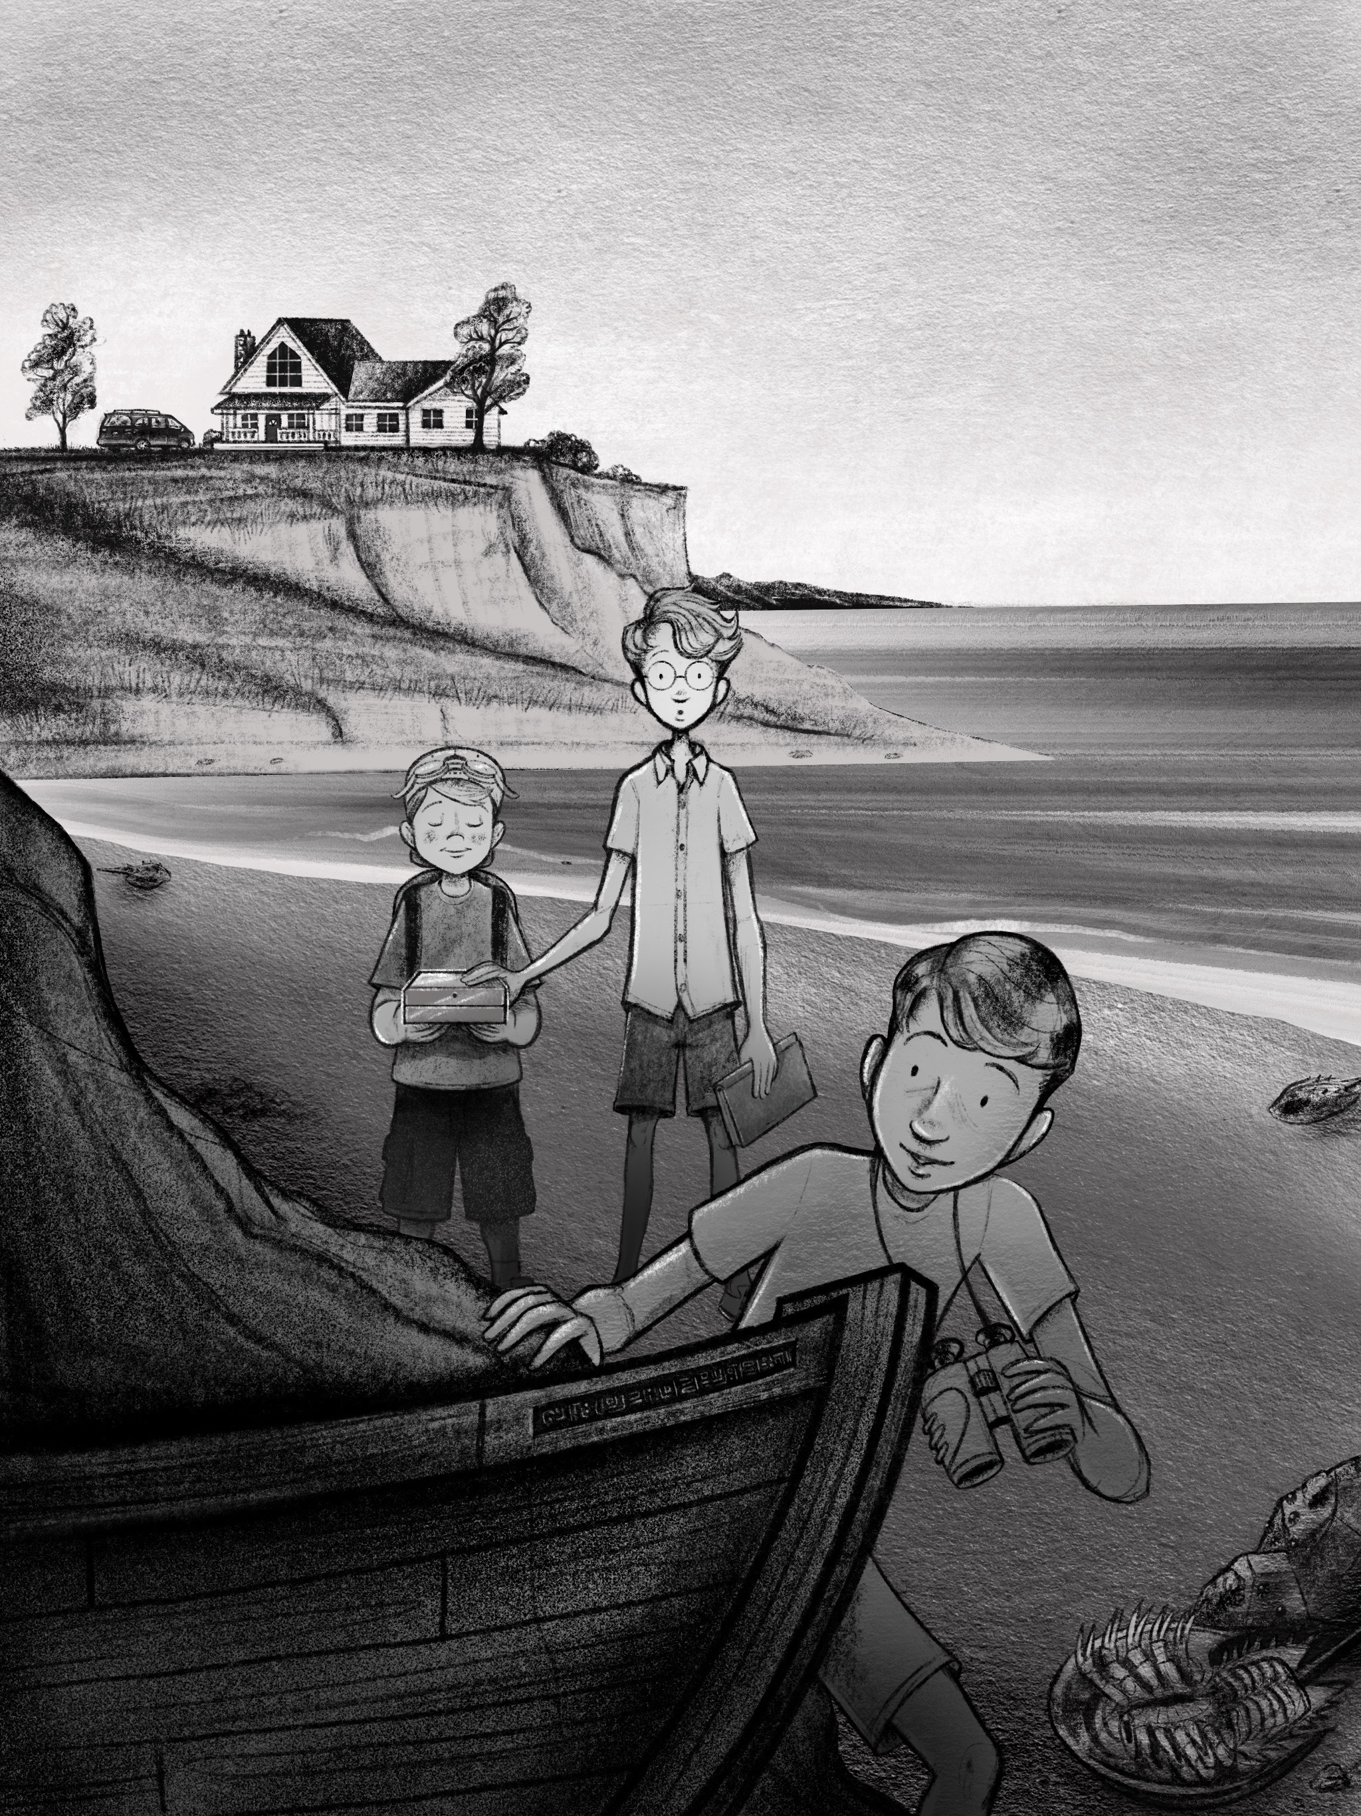

“W
hat boat?”
Arthur asked, bewildered.
Alexander had already reached his little brother—drawn to the shiny, gold object in his sandy little hands. The box was almost unbelievably shiny, as if it was in a perpetual state of being polished. Alexander instinctively ran his fingers along its surface. He noticed that it didn’t leave any smudges or fingerprints at all. The water droplets that touched it quickly ran off and onto the ground. Other than it’s shininess, it was actually a very plain box. A rectangle about the size of 4 standard novels, stacked. The edges were very precise and sharp.
By now, Arthur had reached his brothers and the box.
“This thing must be worth a billion dollars!” Exclaimed Alexander as his older brother grabbed it from Gus’ hands.
“Hey! That’s mine!” Shouted Gus, trying to sound angry but actually quite proud of himself for finding such a special thing that his brothers wanted to see so badly.
Arthur held it up and examined it. There was a very fine line that ran around the middle of the box that was almost imperceptible until Arthur examined it closely with his round specs. The yellow light bounced off the box and onto his glasses, momentarily blinding him.
“Look!” He said proudly. “There’s a keyhole!”
“I know!” Said Gus, who must have already inspected it thoroughly while hiding. “Let me see!” Said Alexander.
Sure enough, there was a small, round hole on one of the long sides of the box, centered above the lateral line. Arthur also noticed that there didn’t appear to be any hinges on the back of the box, and wondered if the entire box split in half once unlocked.
“You think this box is worth a lot?” Arthur said scoldingly to Alexander. “Just imagine what’s inside it! Gus—where did you say you found this thing?”
“The boat!” Said Alexander, who had snuck past all of them.
And there it was. Tucked in behind the boulder was a large, black, wooden rowboat.
“Where’d that come from?” Arthur said, staring transfixed at this mysterious new artifact and handing the box back to an all-too-eager Gus.
The brothers had played all around the boulder over the past week, and were intimately aware of every rock, shell and piece of drift wood in a two mile radius of it. There was no way they could have missed something like this boat. It was new.
Alexander was the first one to touch it and peer inside.
“You’ve gotta check this out, Arthur!”
Arthur was talking to himself as he walked over. “But we were just here yesterday! And there’s no one else that lives anywhere close by...” He was right about that. Their cottage was very isolated. They had driven past a number of homes on their way there—but they were in a pretty remote spot, and there was not another home or building in sight.
Arthur joined his brother next to the boat. He noticed some intricate carvings along the front of its dark hull. As he ran his fingers along the indentations he couldn’t immediately tell if they were letters from some foreign alphabet, or just some kind of decorative pattern. Alexander grabbed the side of the boat, and hurled his skinny body inside.
“Get out of there!” Arthur shouted at his impulsive brother. “That’s not ours!”
“Do you see anyone around here?” Alexander quipped as he began to rummage around the inside of the boat. “It’s ours now!”
Arthur looked around. His brother was right: there was no one else around. Surely if the boat’s owner was still alive, he or she would have headed directly to The Slaughter House. Arthur scanned the ground for footprints—but the area was rocky. He did see a peculiar set of tracks in the sand right next to the boat—but they almost looked like they were from small scuba flippers. He ultimately concluded they were from some kind of large, inquisitive, sea-bird—perhaps an albatross or a pelican—although they really hadn’t seen anything in the way of birds except annoying, small, seagulls this whole trip.
“I guess…” Arthur paused in thought as he put the situation together in his mind. “Who would leave such a valuable treasure in their boat?” He glanced at the box in Gus’ hands next to him.
“A dead person, that’s who!” Shouted Alexander. “This is our boat now—get in here!”
“Fine!” Arthur was dying of curiosity now. He hoisted his right leg over the side and tumbled in.
“I want in too!” Cried Gus, who’s hat and goggles were hardly visible to the two brothers exploring the inside of the boat. “Stop complaining!” Arthur shouted as he rolled his eyes and helped his brother into the boat. First he took the gold box out of Gus’ hands, set it safely on the floor of the boat, and then hoisted his little brother in.
“Well, one thing’s for sure,” Alexander smiled his mischievous smile. “I’m definitely not bored anymore!”
Arthur smiled in agreement. “Hey, maybe there’s a key for this thing! Did you look under the seats?” Alexander had, but they all looked again to make sure. Just like you’d expect in a classic rowboat, there were a couple boards of wood for seats but not much else. And sadly, there was nothing to be found under the seats, or anywhere else for that matter.
“Hmmm.” Thought Arthur, aloud. “It’s a rowboat, alright…but where are the oars?” Sure enough, there didn’t seem to be any oars on the inside. He stood up and scanned the beach around them. There were no oars to be seen out there either. That’s strange! Arthur thought to himself. Who would have taken their oars, but left this priceless box? He turned his attention back to the shimmering box that was back in Gus’ loving embrace.
“We need to open this thing up.” He said as he took the box from Gus and sat with his brothers on the floor of the boat. Arthur pulled out his shiny, red Swiss Army Knife and tried picking the lock with the fingernail file. Every Ficus gets their first pocket knife when they turn ten, and it’s always one of those little Swiss Army Knives that has the little gray tweezers and white toothpick that slide out of one end. Just pulling out this little piece of hardware and using it like it was no big deal gave Arthur a renewed sense of maturity and leadership that felt pretty good. However, what didn’t feel good was the fact that his knife was getting nowhere with the lock. There didn’t seem to be anything to grip onto inside the dark, round hole.
“Give me a try!” Said Alexander as he pulled the box out of his brother’s hand. He tried cramming his short fingernails into the fine indentation that ran around the sides of the box. But it was no use. It wouldn’t even budge.
Gus piped in. “Are you sure there’s even anything in there?”
Arthur took it back from Alexander and shook it. There was clearly the sound of something small softly thudding around inside.
“It’s definitely not metal. That’s weird!” Arthur pushed up his specs. “I wonder what it could be!”
Just then, there was a huge crashing sound. All three boys were knocked over as the boat lurched upward suddenly and then began to slide quickly over the sand toward the open sea.
“We’re going out to sea!”Alexander shouted frantically.
Sure enough, as they had been messing with the box, the tide had mysteriously changed and the waves had increased quite a bit. Now the boat they were in was rocking rather violently, as Arthur struggled to get up and peer over the side. The water had grown dark as the boring gray sky had grown more menacing. Even as large waves began to toss the small boat around, Arthur noticed that they seemed to be getting carried away from shore at an alarming rate.
“It’s a rip current.” Arthur said solemnly. “I’ve heard dad talk about these.”
“A what?” Exclaimed Alexander.
“We’re getting sucked out into the ocean, that’s what!”
Alexander’s eyes were darting back and forth along the shoreline as he grabbed onto the side of the bobbing boat. “Let’s jump out and swim to shore then! C’mon!” He began to lift his right leg over the side of the boat—but his big brother grabbed him by the shirt and threw him to the floor of the vessel.
“Are you crazy?” Arthur scolded .“You’d die before you got to shore in a rip current! We’re safer in this boat and,” he glanced at Augustine who was curled up in a ball and clutching onto the still gleaming box for dear life, “we definitely can’t swim with that box.”
“Also, I can’t even swim!” Gus cried.
Arthur continued, “Our best bet is to try to shout for help! I bet if we all scream maybe even mom and dad would be able to hear us at the house!”
As they looked up, they were startled to see how small The Slaughter House appeared. The current was taking them rapidly in the opposite direction of the house, and out toward the open ocean.
“MOM! DAD!”
“HELP!”
“HELP US!”
All three of the boys yelled and waved their arms frantically as the waves tossed them around. But it was of no use. They could hear their voices being drowned out by the sound of the wind and the waves, and they could see the house begin to disappear in a fog that was developing fast. A deep clap of thunder could be heard off in the distance—and then the rain began.
Pretty soon the entire coastline disappeared into the gray.

Chapter 6: The Waves
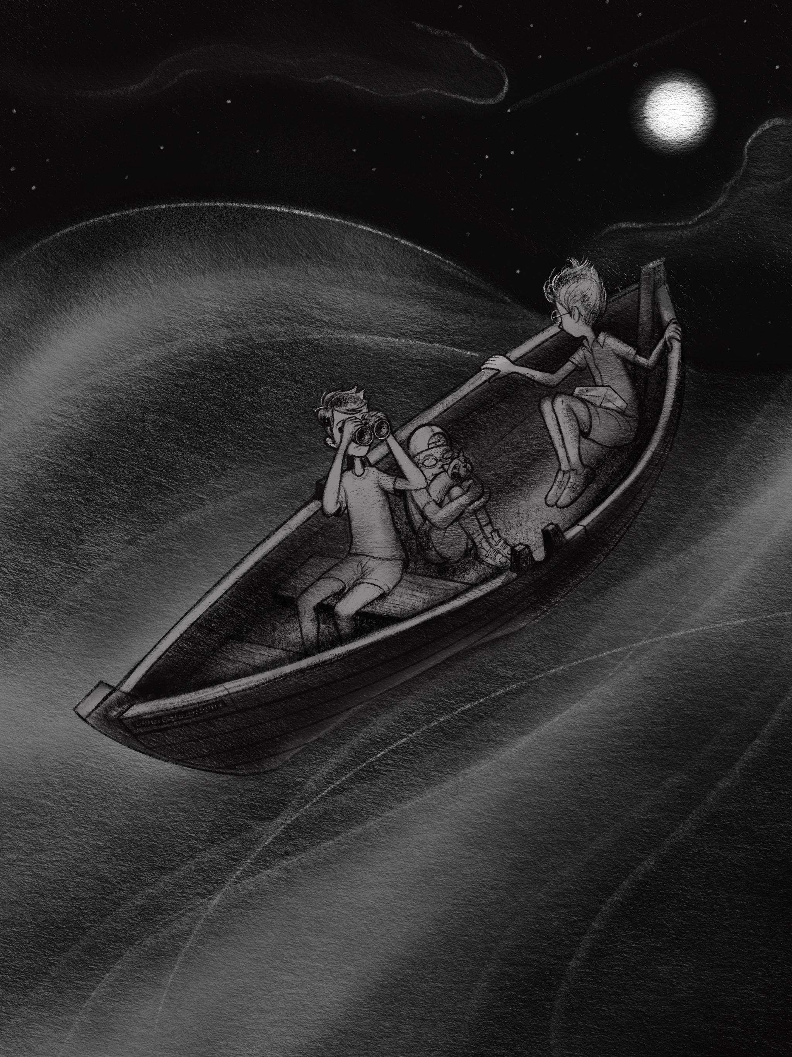

T
he rain and fog had disappeared around the same time that the darkness fell. The sun must have set during the storm because none of the boys noticed a clear sunset. It just seemed like the vast gray had slowly turned into the vast black. The waves began to die down as the darkness grew, and for a time the soaking boys just stared out at the darkness of the open ocean, without saying a word. Their voices were hoarse from shouting for their parents—and shouting at each other—during the storm.
They were exhausted.
That night the moon was huge and pale. And, as it rose, it seemed to disperse the cloudy sky into little cloud lumps. The stars and planets were so clear and bright it was hard for the boys to believe. The endless expanse of ocean and sky before them, excited and terrified them at the same time.
“Well—we’re not in Kansas anymore, that’s for sure.” Said Alexander dryly, after what seemed like hours of silence.
“At least it’s calmed down now, and we can see.” Arthur looked at his Alexander and reached for the binoculars around his brother’s neck. “Can you see anything with those things? Lights? Ships?” He scanned the dark horizon with his brother’s binoculars. Nothing but stars, glimmering water and utter darkness.
Gus was still curled in a ball with the box. His trusty goggles over his eyes and his handy backpack on his back.
“What do you have in that backpack?” Arthur said as he handed the binoculars back to Alexander. Slowly Gus set the box down next to him, took the backpack off his back and unzipped it.
“My harmonica… Cinnamon…”
“Well, a lot of good that stuff is gonna do us!” Alexander said shaking his head.
“Hey! I didn’t know we were going to be stuck on a boat in the middle of the ocean, ok?” His voice started to choke, as if he was just now realizing how alone and lost and in danger they were.
“It’s ok, Gus. We’ll figure this out. I’m sure a ship is bound to find us soon. We can’t be that far from shore.”
Alexander grabbed his belly as it rumbled. “I sure wish you would’ve packed a couple granola bars or something, Gus!”
“Or a bottle of water.” Arthur said as he looked out at the sea, realizing how dry his mouth had become.
Gus started to cry. “Are we gonna die?”
“No, Gus!” Arthur said, sitting next to his little brother and putting his arm around his heaving shoulders. “I’m sure everything will look better in the morning.” Alexander sat on Gus’ other side. “Yeah! As long as this boat doesn’t spring a leak and we all get eaten by spiky-back sharks we’ll be fine!” Gus started crying even louder. Arthur smacked Alexander in the arm. “Shut it! You’re not helping. And those stupid sharks aren’t even real! We’re gonna be fine, Gus.”
Just then, a strong gust of wind spun the boat around, and it began to gently sway side to side. Alexander got up from next to Gus, and looked over the side. “Waves. Looks like the ocean’s picking up again.”
It was the oddest thing. There was no storm clouds or rain, but a steady wind began to blow, and the sea around them began to turn into a vast field of watery, undulating hills and valleys. Up and down the boat went, from crest to trough. At first, they thought a new storm was upon them and that the boat was at risk of being capsized, but it soon became clear that if they all sat still, no harm would befall them. The boat merely bobbed up and down, up and down, again and again.
After probably about an hour of this, the boys began to notice how tired they had become. Arthur, remembering that he was wearing a watch, glanced at it for the first time. “Gee whiz! It’s three in the morning!” He looked over at Gus who was already fast asleep on the floor of the boat, squeezing his precious stuffed red panda. “Zander, we might as well try to get some sleep. I think if we just lay flat here on the bottom we’ll be safe.”
Alexander yawned the biggest yawn of his life, his hair blowing around in the wind. “Ok.” He said as he lay down next to his snoring little brother. “But if we get eaten by Spikebacks in our sleep, I’m gonna kill you.”
Arthur tried to force a nervous smile, as he looked out at the quietly pulsing sea. It looked like an alien landscape to him. Was this the same earth that they’d lived on their whole lives? The round waves reminded him of the green bluffs that his family had seen countless times while driving through rural Nebraska. As he quickly dozed off to sleep next to his brothers, he found himself dreaming about those strong, midwestern hills. Land. The word played over and over again in his mind.
Never before did land sound so good.

Chapter 7: The Land
“L
and!”
Arthur awoke to the sound of Alexander’s excited voice. He opened his eyes and was almost blinded by the brightness. The dark world had turned to white. He sat up, rubbed his eyes and groped along the bottom of the boat for his round specs that had fallen off as he slept. He glanced at his watch. It was almost ten in the morning—that is, if they were still in the same timezone.
“Land!” Alexander shouted again.
Arthur glanced toward his brother at the front of the boat, who was staring through his binoculars intently at the distant horizon.
“Let me see!” Arthur said as he scrambled toward his brother, trying not to rock the boat too much. Gus rolled over and stretched, blinking in the morning light.
Alexander eagerly handed his brother the binoculars. “Do you see it?”
Arthur squinted and adjusted the binocular’s settings. It was always awkward looking through binoculars with his glasses, especially when his eyes were still adjusting to daylight.
“See what?” He said disappointingly as he scanned the horizon.
“Right there!” Alexander said pointing with one hand, and forcing Arthur’s head in the right direction. “That’s land, right?”
“What?” Arthur squinted again. “I mean, I guess I see something. But that could be anything, Zander! That could be a dark cloud or something else for all we know. It’s too far away.”
Alexander stared at his brother, deflated.
“Well I think it’s land! It’s definitely not a cloud! And we’re headed right to it, so we’ll know soon.”
Sure enough, they did seem to be moving at a pretty good clip straight in the same direction as the dark shape on the horizon.
“Weird.” said Arthur as he looked at the clear movement of the dark, blue water. By now Gus was next to them looking through the binoculars too. “Maybe it’s a tractor beam! Maybe it’s pulling us in!” Arthur rolled his eyes. “I don’t think that’s how land works, Gus.”
“Well,” Quipped Alexander. “I sure hope it’s land. I’m starving!” He rubbed his belly longingly. Then his eyes grew wide “Man! What if we get stranded on a deserted island, and we have to forage to survive! Eating random plants and animals! This could be awesome!” His mischievous smile turned on again as he imagined how he would kill and eat various island creatures with his bare hands.
Arthur sat down on the floor of the boat in a huff. “Gross. That sounds absolutely disgusting. Hopefully the tides just turned last night, and we’re just headed back home.”
“Nope.” Said Alexander matter-of-factly. “Because we’re headed east. If we were headed back home, we’d be headed west.”
Arthur hated feeling like his brother was outsmarting him, so he tried to poke holes in his argument. “How do you even know which direction we’re going, smartypants? You got a compass in that binocular or something?”
“I watched the sunrise. And it rose right over there. We’re heading east.”
“Wait, you watched the sunrise?” Asked Arthur, trying to change the subject. “Did you get any sleep last night?”
“A little.” Replied Alexander. “The sunrise was amazing!” He paused reflectively as he remembered the beautiful site. “I also tried to catch a bird for breakfast with Gus’ backpack, but it got away.”
“Huh?” Said Gus, grabbing his empty backpack off the floor and hugging it tight.
“You are so weird, Zander.” Arthur said.
Alexander was back at the binoculars. “I may be weird, but I’m also right. That is clearly land, Arthur! I think I see a volcano or something!”
Arthur sighed as he looked through the binoculars again, preparing for disappointment. But the disappointment never came. There it was, clear as day: land. A rocky peak ascended heavenward, accompanied by some smaller mountainous terrain. As they sailed closer, the tiny, fuzzy shapes of trees began to emerge from the haze of the horizon.
“I don’t believe it!” Said Arthur, mesmerized.
“I wanna see!” Said Gus as he snatched the binoculars from Arthur’s hand. Arthur, speechless just stared in the direction of the land.
“Well, believe it!” Said Alexander triumphantly. “And since I discovered the Island it shall be named Alexander’s Island, in honor of me.”
Arthur rolled his eyes again. “First of all, how can you even tell it’s an island? Also, I highly doubt it’s never been discovered before. Everything’s been discovered by now! I’m sure this place will be crawling with people. Do you see any houses or buildings yet?”
Gus spoke up. “I hope they have breakfast there. I want waffles!”
The thought of their mom’s homemade Belgian Waffles dripping with warm butter and maple syrup sounded so good to all three boys—but as the boat came closer and closer to the land, the more it became clear that there were no signs of modern civilization before them. The cloudy, blue shapes became clearer, greener, and darker as they loomed closer to them out of the atmosphere. They all began to see that Alexander was right after all: it did appear to be a deserted island. A tall peak at the center of the island appeared to be in the shape of a classic conical volcano—the kind you see in cartoons and science fair projects. It seemed very tall to the boys—of course, being from the midwest—even relatively small hills seemed tall to them. The rest of the island seemed to be covered in green foliage—tall, dark trees with a greenish-blue tinge. They looked like nothing any of the boys remembered seeing in any of their botany books back home. Classic palm trees seemed to dot the beach closest to them. This was a special treat as none of the boys had ever seen a palm tree in person before. The discovery of the palm trees gave Arthur pause, as palm trees seemed a bit too tropical for anywhere near Slaughter Beach, Delaware. He began to wonder how far away from home they now were. His mind raced to calculate how fast they were going, how many hours they had been to sea, and tried to figure out how far from home they might be.
“Oh man, we’re almost there!” Alexander exclaimed proudly “My island! This is gonna be fun!”
“For the hundredth time!” Arthur corrected. “This is not your island! Hopefully someone will have a phone and we can just call mom and dad. We’ll figure this out.”
“Whatever.” Said Alexander, not allowing his spirit to be deflated. “You’ll be happy I’m here when it’s time to kill some animals, you’ll see.”
Just then, they all heard it: a sharp, scratching sound coming from under their boat.
The wood vibrated sharply under their feet for a moment, and then it was gone.
Gus shouted “A shark!”
“Calm down!” Arthur said grabbing onto the side of the boat with one hand and hushing Gus with the other.
“We’re probably just hitting a coral reef or something. That was just rock or coral.” He looked over the side of the boat cautiously to confirm his hypothesis. But he definitely didn’t see any coral. The ocean seemed just as deep and dark as before. They were getting closer to the island, but not that close.
“That’s odd.” He said.
Alexander piped up. “Maybe we hit a sea turtle or something! I’m pretty sure that’s illegal.”
“Well whatever it was, it’s gone now.” But no sooner had Arthur uttered these reassuring words that there was another sharp, grinding sound from below. This was followed by a forceful bump that threw all three boys off their balance and onto the floor.
“There’s something down there, Arthur!” Alexander whispered emphatically as another long scratch started toward the front of the boat.
Thud! Scraaatch.
Thud! Scraaatch.
There seemed to be multiple things hitting their boat from different directions. The boat lurched to one side, and then to the other. This time, Alexander peeked over the side—just in time to see a large, dark shape disappear into the deep.
“I see one!” He yelled. “It’s huge!”
Alexander sat back down with wide eyes and his heart clearly beating fiercely in his chest.
“What is it?” Whispered Arthur fearfully.
“I don’t know! But it looked like it could be 15 feet long! Like, a shark or something!”
“A Spikeback!” Said Gus again, starting to cry.
“Gus! Those are not real, buddy! These are probably just playful dolphins or something, that wanna be our friends, ok?”
But just then, as all three boys were trying to calm themselves with this pleasant image of friendly dolphins—the entire boat lurched upwards, clear out of the water—as a dark, razor-sharp barb burst through the floor boards of the boat right in the middle of where they were huddled.
Craaack!
“Spikebacks!” They all screamed in unison.
Saltwater gushed into the boat as the barb wiggled and pulled out of the boat. Before the boys even had time to move, they were hit again, and again, and again. One spike shot up, right behind Arthur. Another under one of the plank seats. Another grazed Alexander’s leg, causing it to bleed. The force with which these creatures were hitting the bottom of their boat was absolutely tremendous. Arthur remembered watching a nature documentary about whales that jump clear out of the water. Whatever these things were, they were going down deep to get momentum.
The boat began to fill with water.
“Quick!” Shouted Alexander, ripping off his shirt. “We’ve gotta fill these holes! Arthur, give me your pocket knife!” Arthur, stupefied, pulled the little red knife out of his pocket and handed it to his brother. Alexander immediately cut his shirt into strips and started stuffing them into the holes on the deck, slowing the leaks. Gus reluctantly shoved his beloved Cinnamon’s striped red tail into one of the holes as well. There seemed to be a slight lull in the creature’s thudding.
“Are they gone?” Asked Gus, fighting back his fears.
Arthur cautiously looked over the side of the boat. “They’re probably going down deeper to hit us again! Get up on the seats so they don’t cut us!”
They all did as Arthur ordered, just before they were hit again.
Craaack!
Thud! Scraaatch.
Craaack!
The boat thrashed around violently with each hit. Gus was thrown off the front seat and began to fall into the water. Alexander grabbed him with one hand, his other hand holding securely to the side of the boat. He quickly pulled his little brother to safety.
Craaack!
Wood splinters, board fragments, and water sprayed everywhere as a two foot hole busted through the center of the boat, right where the boys had previously been sitting. And that’s when they saw it: the dark, sleek, spiky skin of a Spikeback shark. It was grating the wood off the bottom of the boat like cheese grater through cheddar. “I can’t believe it!” Arthur said dumbfounded. “They’re real?”
“We’re gonna die!” Gus cried as the boat sustained another forceful, direct hit. The boat began to crack into two even pieces. There were clearly several sharks working together to take their vessel down. As one finished its ear-splitting grating, another began rubbing its spiky skin over the hole right in front of their faces. They all saw its dark, baseball-sized eye, dilating in the light. It fixed upon the boys and then disappeared into the depths.
“It’s gonna come back!” Arthur shouted, clutching onto the sides of what was left of the boat.
“Guys!” Alexander shouted as he looked over the bow. “We’re almost to the island! I think we can make it!”
Alexander was right. The white, sandy shore was looming very close—about ten meters away. They could see the water getting lighter, and shallower ahead of them. A faint glimmer of hope washed over the frightened boys.
“Maybe we should jump!” Alexander said, eyeing the shallows approaching.
“If we jump, they’ll eat us!” Arthur screamed.
Just then, there was a horrible crash—that nearly knocked Alexander into the water. They turned their heads to see the horrifying, snaggletoothed face of a gigantic Spikeback that had crashed all the way threw the hole and was wriggling its way toward them. Its terrible jaws snapping viciously close to the boys.
“If we stay they’ll eat us!” Alexander screamed over the commotion.
Chomp!
The shark’s teeth sank into Gus’ backpack and it began to pull him toward the hole. In a moment of courage, Alexander realized that he was still holding his older brother’s small pocket knife, and it was open. Tapping into a deep primal instinct of protection and love Alexander leapt full-force toward the giant beast and his helpless brother. He began to ruthlessly stab the shark’s tender nose with the one inch blade.
Stab, stab, stab!
In pain, the shark opened its mouth and started wriggling backwards. Gus fell forward in the watery hull of the sinking ship. Alexander grabbed his arm and helped him up to the front of the boat where Arthur was standing with mouth agape.
“Are you guys alright?”
Gus barely had time to nod, when Alexander screamed, “Jump!” At that moment, three enormous, glistening sharks slammed into the sinking boat—giant jaws snapping and chomping vigorously. Alexander grabbed Gus’ arm and tackled Arthur off the front of the boat and into the shallow waters of the reef. Arthur’s entire body submerged under the warm water, and he forcibly hit the sandy bottom with both of his flailing brothers on top of him. He instinctively began to swim, but realized it was just barely shallow enough for him to stand. Miraculously his glasses hadn’t fallen off in the struggle. He looked back in the direction of the boat—it was now almost a stone’s throw away—to see the menacing shapes of the three ferocious sharks flopping around in the midst of the shattered vessel. Arthur thought they almost looked more like poisonous vipers with their sharp, scale-like spines and the way they writhed and wriggled. Just then, one of the sharks locked onto him with its hauntingly dark eyes and then crashed into the water. “Run!” Arthur screamed as he tried to run toward the shore in water up to his chin. He saw Alexander and Gus ahead of him almost to shore. He realized he had a better chance swimming at this depth, so he swam with all of his might. Through the splashing and thrashing he could hear Alexander and Gus’ voices yelling his name. Was this it? Was he really about to become the lunch of an imaginary shark? The day before, he had been paralyzed with boredom—but now his heart was beating harder than he ever knew it could.
He glanced back and he saw it. The gaping mouth of the shark was almost as spiky as its outside. It was so much faster than him—the distance between them was closing fast. He could almost feel the teeth snapping through his leg bones like toothpicks. Then, mysteriously, the shark began to get smaller. It was still chomping and thrashing ferociously in the surf, but it appeared to be stuck in place. That’s when he felt his hand grabbing sand. The water he was swimming in was less than a foot deep, and the shark was stuck in the sand.
He was safe.
Alexander and Gus splashed over in the shallows and helped their big brother up to his feet. They looked over at the angry, stuck shark wriggling backward, convulsively, like a seal. The dark, spiky dorsal fins of five other sharks circled the water by what was left of their boat. Finally free of the sand, the shark joined his companions and they slowly disappeared into the depths.
“Well, that was fun!” Said Alexander between hard breaths. Arthur was bent over in exhaustion. Gus was miraculously still holding the shimmering box, his tattered backpack on his back, his soaked stuffed red panda sticking out of the top. Gus was staring at the vast, green, tropical landscape in front of him.
“I don’t think they have waffles here.” He said sadly.

Chapter 8: The Amphibian
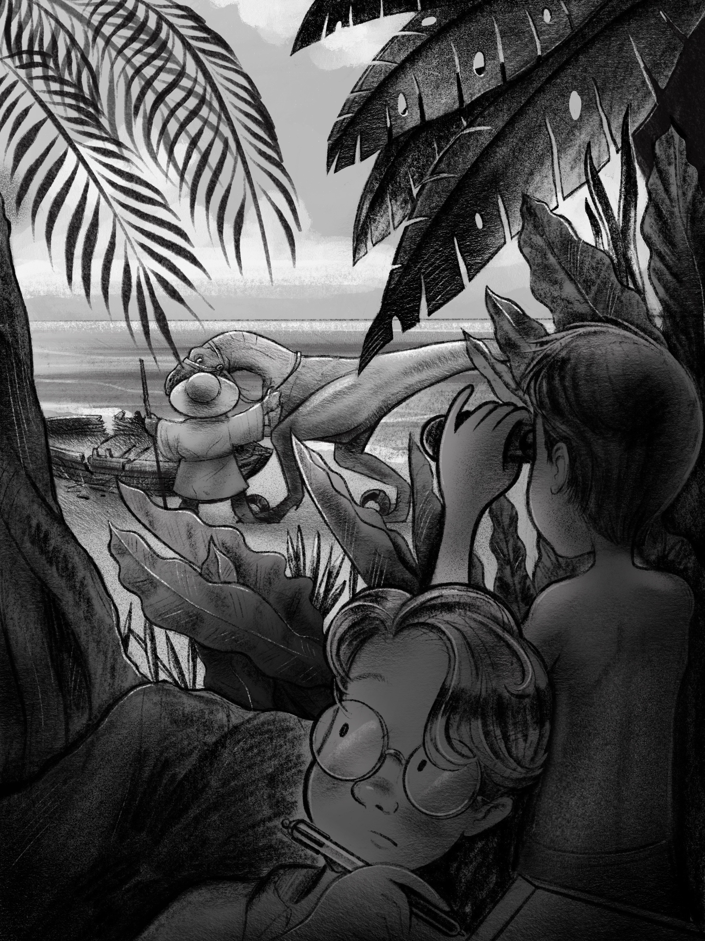

“W
hat do we do now?”
Arthur was staring blankly at the jungle next to Gus. The island was alive with unique sounds, smells and sights. The palm trees looked very similar to ones they had seen in magazines and postcards, but some of the birds flying by looked and sounded very unique—like nothing they had even seen at their local zoo.
“Well,” said Alexander confidently, “since I discovered this Island, I have named it Zanderville, after myself. I think it only fair that I be the leader.” He was already crouched on the beach working to tie Arthur’s open pocket knife onto the end of a straight stick with one of Gus’ shoelaces
“Zanderville?” Arthur said unamused, turning around to look at his confident younger brother. “What the heck are you doing? Hey, that’s my knife!”
“I, Alexander Ficus, am making a spear with your knife in order to kill wild prey.” He looked smugly at his bespectacled, bewildered older brother. “I mean, are you really gonna hunt, kill and cook wild animals for our lunch, Arthur?”
“Well, no…”
“That’s what I thought! So, I think it would probably be best if I borrow the ol’ knife for awhile. Wouldn’t you agree?”
“I mean, I guess...” Arthur thought frantically of a reason to take back the knife. It was very special to him, but Alexander had already proven how fiercely and expertly he could wield it with the shark. Killing a wild animal sounded like one of the most horrifying things Arthur could imagine.
“It’s settled then!” The shirtless, shoeless Alexander exclaimed happily as he stood up brandishing his new weapon. He was already looking pretty wild and fierce, and they hadn’t even been on the island five minutes. “Now let’s go into this jungle and find something to kill and eat!” He turned around and began to walk toward the trees.
“Wait a minute!” Arthur shouted after his brother. “It’s not settled! I’m the oldest, so I’m the leader—and I don’t think we should go into that jungle.”
“And why not?” Alexander said as he put his free hand on his hip.
Gus stood between them, silently and faithfully holding the gleaming box.
“Because…” Arthur stalled as he looked up at the mysterious expanse of trees and the dark volcano looming in the distance. “Because…we have no idea what’s on this island!”
“What do you mean?” Alexander was getting curious now.
“I mean—” Arthur continued, “we were just almost eaten by a pack of make-believe sharks covered in razorblades—who knows what kind of horrible creatures live on this cursed island!
Just then a shrill, sharp cry came from far off in the distance. The boys wondered if it was just another undiscovered bird or something more sinister.
“I just think we could be walking into a trap in there. We need to stay along the shore and see if we can find someone who can help us—a boat or a house or something.”
Alexander could definitely understand where his brother was coming from, but his belly was rumbling.
“I don’t know about you, but I’m pretty darn hungry—and I don’t see any food lying around! I’d love to go do some fishing here on the beach, but I’m not about to go anywhere near those sharks again. I’m sure this is just your standard desert island. Nothing too freaky. Who knows, maybe we’ll find some fruit in some of these trees!”
Arthur was hungry too. He glanced at his watch. It was almost noon, Slaughter Beach time. He realized that none of them had eaten or drank anything since lunch the day before.
“Zander, I want to find food too—but I don’t want to become food in the process! Maybe we can just stay closer to shore and see what we find on the beach first?”
Alexander rolled his eyes.
“Fine. But if we don’t find anything edible in the next hour I’m going hunting.”
Gus grabbed his rumbling belly, and followed his brothers.

The first edible item they found was something they assumed was a sort of coconut. They were about the size of a football and growing off the tops of the palm trees. They had the hard, furry shell of a traditional coconut—but the most peculiar deep, purple coloring. Alexander was the first to spot one on the ground—unfortunately it was rotten. He then proceeded to shimmy straight up the trunk of the shortest palm tree he could find and tossed a couple fresh ones down to his hungry brothers. They managed to get them open with the help of Arthur’s trusty Swiss Army knife and a large sharp rock. These midwestern brothers hadn’t ever eaten a fresh coconut before but they knew that this fruit before them had a different taste and texture than any fruit they could imagine back home. The “meat” of the Purplenut—as Gus jokingly referred to it—had a bright fleshy color, a fibrous pineapple-like texture and a savory, salty taste . The “milk” had a brothy flavor. They were all pleased with how nourished and full they were all feeling after eating and drinking just a little bit. Purplenut reminded the boys of their mom’s chicken noodle soup that she would whip up from scratch in the middle of a deep, dark, snowy winter when everyone would be inevitably coming down with a miserable head cold.
“I miss mom.” Gus said, after taking a long slurp of the Purplenut milk.
“Me too.” Sighed Alexander, staring at the sand.
“We’ll find mom and dad.” Chimed in Arthur assuredly, as he grabbed the Purplenut from his little brother for another nostalgic swig of the brothy milk. “I’m sure there’s gotta be some kinda house on this island. I’ve got dad’s phone number memorized—we could be talking to them in just a bit!” He looked off into the jungle, trying to see if he could find even a remote hint of civilization. Only the towering, dark volcano in the distance stared back. Although he spoke reassuringly to his brothers, the truth was that Arthur’s thoughts were plagued with a sickening pang of doubt. Maybe they were really alone after all.
Just then, all three brothers heard a rustling of branches off in the distance and what sounded like the fast footsteps of something large coming toward them in the jungle. The same shrill, bird-like cry they had heard earlier now sounded like it was less than a football field away from them, and heading their way. “Quick! Hide!” Alexander whisper-yelled as he grabbed his pocket-knife-spear and pushed his brothers off the beach and into the foliage at the mouth of the jungle. The three of them tumbled into the forest, crouching and trying to be as quiet as they could. “Shhhh!” Alexander grabbed Arthur’s shirt and pulled him to the ground, in a heavily forested spot. “Listen!” Arthur stopped, adjusted his round specs, and peered between the leaves at the beach. He didn’t see anything, but he heard it. The unmistakable sound of a voice.
“Is that singing?” He whispered.
Sure enough, the loud crunching of footsteps was accompanied by the sing-song voice of what sounded like an old man. Half humming, half talking. Neither Arthur nor Alexander could make out what was being sung. “He sounds friendly! Should we go introduce ourselves?” Arthur wondered. “Wait!” Alexander pushed Arthur down again, as he peered through the small spot in the leaves.
“I see something!”
He quietly lifted his binoculars.
“Do you see him? What does he look like?”
Arthur asked, dying of curiosity. Instead of a response, he saw his little brother’s mouth drop open in a speechless stupor. Slowly he lowered the binoculars from his wide eyes.
“It’s a…”
“What is it?”
Arthur grabbed the binoculars and peered for himself, as Alexander finished his sentence.
“Dino!”
“What the—?”
Arthur was entranced by the sight.
“It’s a raptor!”
Sure enough, the dark form of a two-legged, ancient reptile came into view, plodding gracefully in the sand toward the broken remains of their boat. “How?” Alexander stammered, still dumbfounded. “I have no idea!” Arthur couldn’t stop staring. “Hey, there’s someone on its back!” There was a small cloaked figure sitting atop the dinosaur’s back, wearing a wide-brimmed hat, and holding a stick of some kind. Both figures were in shadow, so it was hard to make out their features.
Cautiously, the dinosaur stopped next to their battered boat, sniffing it curiously. The shadowy figure on its back hopped off with more agility than either of the brothers would have expected from someone of the figure’s stature. It hobbled over to the boat, and poked it a bit. He seemed to be muttering something to his reptilian steed. Then the figure got very quiet and crouched down in the sand. Arthur was the first to notice the remnants of one of their Purplenuts in the figure’s hands. He appeared to sniff it, then set it down slowly—his back turned toward the boys.
What happened next, was a moment that would be burned into Arthur and Alexander’s minds forever.
Without any kind of warning, the figure’s hat-bestrewn head, whipped around in an instant and he to stared directly at the boys. At once, both boys realized that the figure before them was not human at all. Two giant, golden eyes, with large rectangular pupils fixed directly on them. Its wide, frowning mouth stretched from shoulder to shoulder, and there were two large holes where a proper nose should be. The thought popped into both of the boys heads at the same time.
“It’s a frog!”
Without losing another second, the seeming amphibian yelled the most peculiar thing, at the top of it’s lungs, in the most deep, clear, manly voice:
“REBEKAH!”
In an instant, the large dinosaur bounded straight for the brothers huddled in the bushes. “Run!” Alexander screamed. Both brothers jumped to their feet, but it was no use. With one gigantic leap, the prehistoric creature jumped clear over the brothers and turned around suddenly, bearing its sharp, dreadful teeth at them. The brothers nearly ran straight into the dinosaur’s nose—their chests heaving with fear and adrenaline.
“It’s no use running, boys!” The deep voice came from behind them. “Rebekah could slit your throats—grooock—before you take your next move.”
Both boys kept staring directly at the crouching, muscular, bundle of teeth and claws before them. Rebekah’s eyes were piercing, and her tongue moved up and down hungrily behind her glistening, razor sharp teeth.
“We come in peace!” Alexander said as he dropped his knife-spear and raised his hands in the air. Arthur followed suit—his arms shaking violently in fear and his eyes transfixed on the dinosaur’s snarling jaws.
“What brings you to our—grooock—island?” Croaked the voice from behind. They could hear that the frog was hobbling toward them across the sand and brush.
“We’re lost!” Exclaimed Arthur, almost in tears. “It was an accident—we don’t know where we are!”
“An accident?” The frog’s croaky voice was now right behind them. “How do a couple boys—grooock—accidentally sail to the shores of an ancient and cursed island?”
The frog jabbed each boy in the back with his staff. “Turn around!” He commanded. Slowly, both Arthur and Alexander turned around to face their captor—their hands still in the air and shaking. The frog was a little shorter than them, and was crouching on his haunches—staff in hand. There was a quizzical scowl across his shiny, bumpy, mint-green face. Although he was smaller than them—he was by far the biggest frog they had ever seen, and they were astounded by his size.
“Where did you get that—grooock—boat?” And then his eyes seemed to shine with tears as his voice broke. “And where’s Santiago? What have you done with him?”
He quickly pointed the end of his staff in Arthur’s face, and then Alexander’s, then back to Arthur’s. His eyes darting back and forth between them, wild with anger.
“Santiago?” Alexander started, “We haven’t seen anyone, we promise!”
“Who’s Santiago anyways?” Arthur asked, as he started to lower his trembling arms. Alexander did the same.
“Spies! For all I know you killed him for his boat! Buccaneers! Mark my words—why should I trust you at all? There’s probably hundreds of you hiding in these—grooock—bushes!” His eyes darted up toward the tops of the trees, and his staff followed his gaze. He seemed to be paranoid with grief.
“Honest!” Arthur continued. “It’s just the three of us brothers here! We’re not spies, we promise!”
“Three? Perhaps in the faraway land that you come from, numbers are different. But on our island—grooock—the number represented before me is called two, not three. Mark my words!”
They same thought struck Arthur and Alexander at the exact moment.
Gus was nowhere to be seen.
Their heads darted back and forth, and they began to spin around. It had all happened so fast. The spectacle of a toothy velociraptor and a talking frog had distracted them from noticing that their littlest brother was missing.
“Gus!” Arthur gasped.
“Augustine!” Alexander cupped his mouth and yelled at the top of his lungs, spinning around and scanning the jungle behind Rebekah.
“This Gus. Is he your brother?” The frog’s voice was quieter, more tender than before. He seemed to be deep in thought.
“Yes!” Arthur responded “Gus! Where are you?” The veins were bulging in his neck. The thought of his little brother lost in these dark and strange woods was almost more than he could bear. Tears began to well up in both of the brother’s eyes.
The frog let out a sigh.
“Well, we have no time to lose, mark my words! There are fowl things in this forest—grooock—fowl things I say! But Rebekah here has the nose of a blood-hound. I’m sure she can find your brother. Gus, is it?”
“You mean—you’re not gonna have your dinosaur kill us? You don’t think we’re spies anymore?” Alexander exclaimed, wiping the tears from his eyes.
The frog looked Alexander squarely in the eyes.“No buccaneer would cry the way you did for a lost brother. I know that feeling well—grooock— I feel the same way for my Santiago.” He choked back a tear as he hobbled over to Rebekah and swung himself up on her back in a graceful hop.
“Is this Santiago your brother?” Arthur mused.
“No.” The frog croaked softly as he stared off into the jungle.
“He’s my son.”

Chapter 9: The Hunt
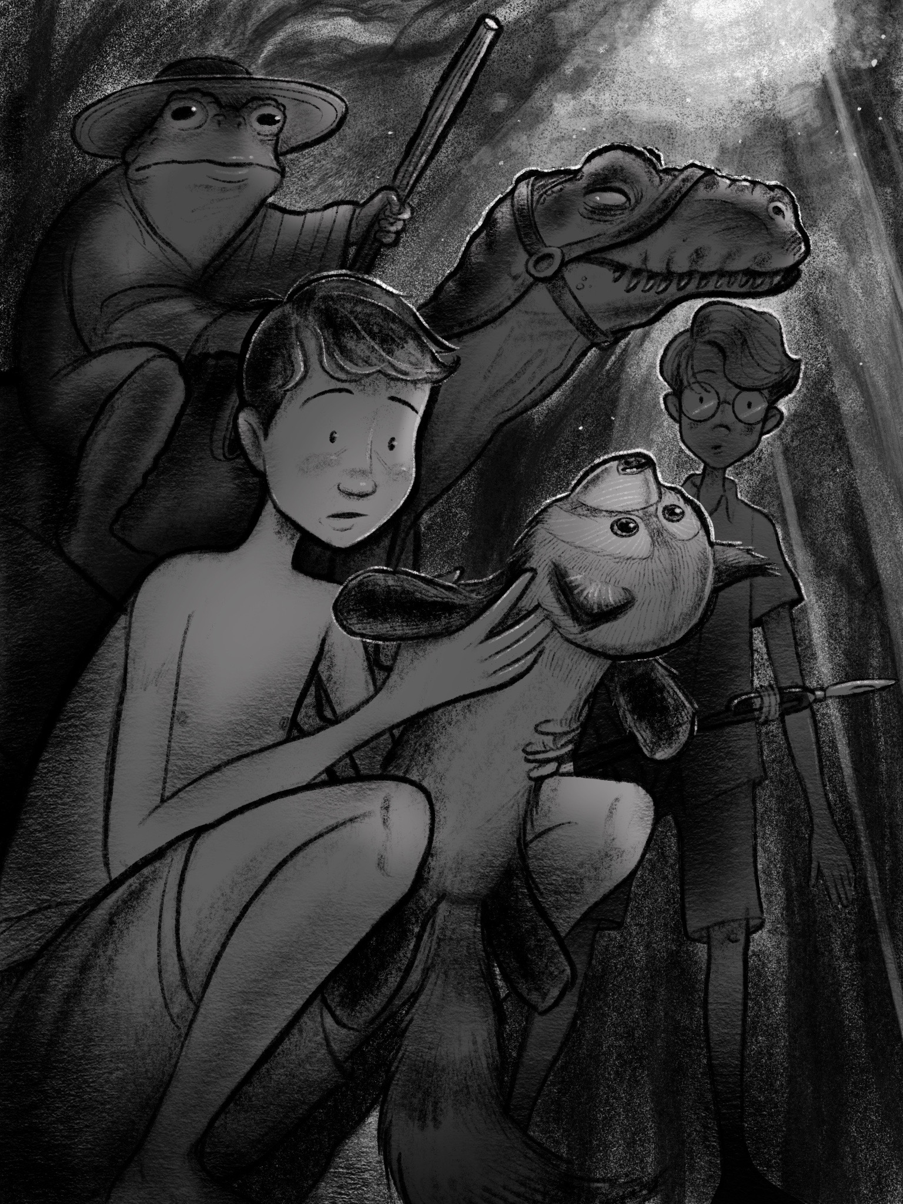

A
rthur and Alexander struggled to keep up with Rebekah’s brisk pace through the jungle vegetation. She sniffed the ground ahead of her like a dog—jumping over fallen trees and ducking under branches so expertly it was as if she had an internal map of every piece of foliage. All along the way, the frog would shout random things to his trusty dinosaur, as well as words of encouragement to the exhausted Ficus brothers lagging behind.
“It won’t be long now!” The frog shouted back to them as they almost ran into a tree branch.
“Rebekah’s on his trail now—grooock—mark my words!”
The brothers shouted Gus’ name until their voices were both hoarse. They couldn’t believe that their little brother could have run this far in such a short amount of time. Had he been snatched by some kind of jungle creature? Why would he have run so far away from them? Why hadn’t they noticed he was missing sooner? Guilt and fear kept bubbling up in both of the brother’s hearts as they ran. Alexander began to wonder if they might happen upon some kind of frightful creature devouring the remains of their brother. Arthur feared that they wouldn’t find him at all.
Then, after making a sharp turn in the forest, they heard it. A loud, rushing sound filling their ears.
Rebekah stopped.
It took Arthur and Alexander several seconds to catch up to the vigilant dinosaur and her rider. They were standing on the banks of a raging river, full of rocks and violent rapids. It must have been forty feet to the other side. In an instant, they knew there was no way Gus could have made it across.
“He can’t swim!” Arthur blurted out, tearing up.
“Is Rebekah sure he went this way?” Alexander stared up at the old frog.
“I’m afraid so.” Replied the frog slowly. Rebekah bobbed her head up and down, seemingly in agreement. “This is where the scent ends. He must have fallen in.”
“He wouldn’t have!” Arthur shouted.
Alexander didn’t waste any time. He simply began to run along the bank of the river shouting Gus’ name, his makeshift spear pumping up and down in his arms. The rest followed him.
“Augustine Ficus!” Alexander screamed as he jumped over rocks and sticks along the winding shore. The raging waters beside him seem to drown out his voice entirely. “Gus!”
And then he saw it.
Snagged on a branch hanging in the rapids a few yards away, was their little brother’s beloved red panda toy, Cinnamon, soaked and tattered.
“Nooo!” Arthur screamed when he saw it.
Alexander ripped it free from the branch and fell to his knees in the mud of the riverbank, sobbing uncontrollably.
“I’m so sorry, my boys. But it appears your brother is gone.”
Arthur just stood there staring at Alexander on the ground, his chest heaving from the chase. So many emotions were washing over him at the same time.
Suddenly, there was a thunderous boom that broke through the thunder of the water. It came from the direction of the beach they had just left.
“Winnifred!” The startled frog half whispered half shouted. Fear gripped his giant, golden eyes as he tugged on Rebekah’s reigns. “We must hide!”
“Who?” Asked Arthur, shaken out of his grief for a moment by a newfound fear for his own life.
“No time to explain—grooock—we must fly! He’s on our trail to be sure, mark my words!” And with that, they were off again—this time running away from the river and toward a smaller mountain range, opposite from the great volcano.
Alexander grasped his lost brother’s beloved Cinnamon tightly as he ran—tears streaming down his reddened face.
Rebekah didn’t stop to sniff. She seemed to be on autopilot. Several times the physically and emotionally exhausted brothers would lose sight of her, but she would always re-emerge, beckoning them on. The boys had never run like this before. They were too blinded by fear and grief to notice the peculiar flora and fauna flying past them. Right now their minds were set on survival.
The only thing they noticed about their terrain was that they were clearly going uphill—and sometimes drastically so. At several spots they were climbing more than they were running. Rebekah’s remarkable agility made it look so easy—simply leaping over entire areas that they had to struggle strenuously to climb over. Both boys were curious who this “Winnifred” was and what he could possibly want with a couple boys and a frog.
Just as both boys began to wonder if they would die from exhaustion, the tireless dinosaur stopped. She was standing in the middle of a grassy clearing, against a sheer rock cliff. The brothers followed the wall of dark volcanic rock upwards with their eyes. The bright sky shone down from above. It appeared they had reached the foot of the mountain range.
“Where do we go now?” Alexander panted between breaths, buckled over his knees.
“There!” Cried the frog as he pointed up at the rocky face. Sure enough, there was a small cavern in the cliff about thirty feet above their heads. The frog held his staff like a javelin and expertly tossed it directly into the open mouth of the cave. He then proceeded to leap clear off of Rebekah’s back and onto the rocky cliff. He smoothly scaled the sheer wall in a matter of seconds, his movements reminding the boys of a pet tree frog they had once had. In a moment, he disappeared into the opening of the cave.
“Rebekah! Come!” The frog’s voice echoed from the cave.
The large dinosaur crouched its lean body low to the ground and then sprung into the air like a rocket—vanishing into the cavern entrance with a single bound.
The Ficus brothers stared at the cliff with disbelief. There was no way they could climb like the frog or jump like the dinosaur.
“What about us?” Alexander shouted up at the cave.
His question was met with silence.
Had this all been a trap?

Chapter 10: The Cave
A
nother cannon blast came from behind them.
Boom!
The boys began to panic.
“Frog!” Arthur called up at the opening in the cliff, realizing for the first time that—although he knew the name of his son and the name of his reptilian steed—he did not actually know the name of the frog himself.
There was yet again no answer.
Just as the boys were about to give up hope, they noticed what appeared be a rope being lowered slowly from the mouth of the cave.
“Oh, calm down! Mark my words…” Came the frog’s grumbling voice, his bright eyes peering from the dark opening.
The brothers breathed a collective sigh of relief and hurried over to the descending rope. As they reached it, Arthur noticed that it was clearly handmade—made by twisting various vines together. Alexander was the first to try to climb it, but quickly fell off. Although he could shimmy up a tree with ease, he had never tried scaling a wobbly rope before.
“Don’t climb it!” Scolded the frog.“Just hold on!”
The brothers did as they were told, and they were surprised when they were quickly lifted straight off the ground, and directly toward the mouth of the cave. Within seconds, they found themselves panting on the cavern floor in a heap—a little scratched up, and even more confused.
Arthur squinted into the dark of the cave. He could see the other end of the rope was tied around Rebekah’s waist—she had hoisted them up with her own strength. Arthur thought this was a pretty smart solution.
“Thanks—sir.” Arthur paused, remembering that he still didn’t know his host’s name. The frog chuckled.
“I don’t know your names either, you know!”
“Oh! I’m sorry—my name is Arthur Ficus. And this is my brother Alexander.” Alexander nodded toward the frog. “Hello!”
“Well, Arthur and Alexander Ficus—my name is Frederick.”
Frederick smiled, bowed, and took off his hat politely as he introduced himself. He tossed the hat onto a wooden shelf along the cave wall. His smile quickly turned to a look of sadness as he continued.
“I’m so sorry about little Gus.”
Arthur’s face mirrored the frog’s sadness, but Alexander’s expression was one of determination.
“Mister Frederick—we’ve got to go back out there! Gus could still be alive!”
Arthur stood up, filled with emotion. “He can’t swim, Zander! He’s gone—and you know it! He would never let go of Cinnamon unless…” His eyes filled with tears again as he looked at the soaked stuffed animal still in Alexander’s grip.
“We don’t know that, Arthur. We don’t know what happened! I won’t believe he’s actually gone until…” He stopped himself—afraid to utter what popped into his mind. “Well, until…I see better proof than this, anyways!” He held his brother’s beloved red panda up defiantly, almost as if it were proof that his little brother were still alive. Alexander walked over to the opening of the cave, looked out over the jungle, and up to the sea in the distance.
“Maybe this Winnifred you mentioned kidnapped him. Would he do something like that?” He turned around and looked at Frederick. The frog sighed. “Oh—grooock—he would kidnap! And much worse than that, mark my words! If ol’ Winnifred snatched him—grooock—he’s as good as dead! I hope, for your sake, that he hasn’t been snatched.” The frog hobbled over to where Alexander was standing, and gazed out at the jungle himself. He placed his cold, moist hand on Alexander’s bare shoulder. “But I admire your hope, son. As foolish as it might be—sometimes a hope is all we have.” He swallowed back a tear. “And your hope for your brother…gives me hope for my son.”
“Santiago?” Alexander asked.
The frog nodded silently.
“So what happened to your son, anyways?”Arthur chimed in from behind them.
“That’s a long story, mark my words…” Frederick replied. He turned around to face Arthur. “And a story that I, sadly, don’t know fully myself yet! There are many missing chapters…missing pieces. I was actually hoping that you two might be able to help me fill in some the—grooock—blank spaces.”
“Us?” Arthur started. “What could we possibly know? I told you—we haven’t seen any other talking frogs, I swear!”
Frederick continued, “So you say…” A look of mystery came over the frog’s face. “But you still haven’t told me how you came upon Santiago’s boat, have you?”
“Santiago’s boat?” Alexander exclaimed with surprise.
“Boys, there’s much to explain and much to discover. But for now, we have some important business to attend to. It will soon be getting dark and I’m sure you’re both hungry and thirsty.” He hobbled over to where Rebekah was resting on the ground in the dark of the cave. He patted her head affectionately. “We need to get a fire going and to get dinner prepared. We can discuss missing puzzle pieces over dinner.”

After a few minutes in the cave the boys eyes adjusted surprisingly well to the dark. They discovered that the cave was fairly well furnished with makeshift wooden furniture, various cushions for seats, and a stone fire pit in the center of the main area.
Under Frederick’s supervision, Arthur helped to assemble a campfire using some random dry sticks and logs that had been piled up against the wall. Alexander was tasked with helping prepare the food for cooking. Frederick showed him a woven basket full of fresh produce including Purplenuts, as well as various brightly colored fruits that he’d never seen before. Chopping the fruit on a wooden counter with his older brother’s pocketknife was easy enough. He enjoyed seeing the different colors, textures, and tastes of the exotic new fruit. However, just as he was almost done preparing the produce, Frederick tossed something on the counter that made him jump.
A pile of giant, bright green, wriggling, squirming worms. Apart from their color and unusual size, they looked very much like earthworms that Alexander would find in his mother’s garden back home.
“What am I supposed to do with these?” Alexander questioned.
“Well,” the frog casually replied “I doubt you want to eat them whole…” he grabbed a fat one and quickly slurped it down. His eyes closed and reopened as he swallowed. “So, just chop them up! We can roast them over the fire if you’d like.”
Arthur walked over from stoking the fire. “That’s gross!” He exclaimed with his tongue hanging out in disgust.
Alexander shrugged, and just started chopping—each section writhing independently as he chopped. The frog chuckled and popped one of the pieces into his mouth as he walked back over to the fire.
The highlight of the meal, of course, was the water. Neither boy had had any fresh drinking water in over a day—and they were absolutely parched. Frederick showed them a spot in the back of the cave that contained a pool of crystal clear water that was fed from an ancient aquifer from deep below the island. The frog only had one large hand-hewn wooden drinking cup—so they passed it around eagerly all night, drinking deeply of the clean, cold, sweet liquid. It was unlike any water they had ever tasted before.
Frederick called the worms, simply, tree worms—as they actually wrap themselves around trees and burrow through them, as opposed to living underground. To cook them, the frog showed Alexander how to slide the thick segments onto a thin metal pole and roast them over the open fire, much like roasting a marshmallow back home. In fact, the diameter of the worm sections was very similar to the diameter of a regular-sized marshmallow. Alexander was the first to try some, once he had roasted them a nice golden brown. He was surprised by how sweet and satisfying they were. The taste and texture reminded him of one of his favorite sushi rolls at a Japanese restaurant the Ficus family would visit for special occasions. After much convincing, Arthur eventually tried some—and soon they had devoured everything that Alexander had prepared.
With their bellies full of worms, water, and Purplenut broth, the boys and the frog relaxed on cushions next to the dwindling fire. Rebekah had eaten a couple handfuls of live tree worms earlier in the evening and was curled up and fast asleep at Frederick’s feet.
“Thanks so much for the food, Mr. Frederick!” Alexander said smiling, and rubbing his bare belly.
“Yes! And the water!” Arthur said as he grabbed the wooden cup for the millionth time and took down another cool, refreshing gulp. Water trickled down the corners of his mouth, and glistened in the firelight.
The frog chuckled a croaky, satisfied chuckle and folded his sticky fingers over his round belly, leaning up against Rebekah’s giant, sleeping form like a backrest. His eyes gleamed contentedly as he looked over at his two relaxing guests. He let out a hearty grooock and began to speak.
“Well, I suppose we should get the story out of the way, before you two fall fast asleep—mark my words!”
Both boys shifted upright, as if snapping out of a trance. They had both been blinded by the feast and almost forgotten about the story.
“Yes!”Alexander shouted.
“Please tell us your story!” Arthur chimed in, motioning the wooden cup in the air, in the form of a toast.
“Me?” The frog said shifting up in his seat in alarm.
“Your story first!”

Chapter 11: The Monster
G
us was running for his life.
His little mind could barely process what he had unmistakably just seen—a ferocious dinosaur coming right at him on the beach. He knew that his brothers must be right behind him, so he ran as fast as his little feet could take him. The shiny, golden box still under his arm as he dashed through the dark jungle.
Just when he thought he might collapse in exhaustion, he found himself trapped in front of a raging river running through the forest. He stopped for the first time to ask his brothers what they should do, and that’s when he realized they were nowhere to be found.
“Arthur? Zander?”
His eyes darted back and forth through the green thicket he had just emerged from. There was no sound. No movement. His eyes began to fill with tears, as a horrible thought popped into his head:
They had been eaten.
He had seen dinosaur movies before, and he knew how smart, ruthless, and cunning an adult raptor could be. Two young boys would be no match for a creature of that kind of intelligence and strength. The thought flashed through his mind that, perhaps, he should go back and try to save them. But just as soon as that idea materialized, it vanished as he realized that there was no way they could have survived. If they were not here with him, they were undoubtedly being eaten alive by that prehistoric predator.
Tears welled up in his eyes. He felt like curling up in a ball and just giving up. But then he thought of his big brothers. What would they do if they were here? Deep down he knew that they would find a clever way to get across the river. He wiped the tears from his eyes with his free arm, swung the backpack off of his back, and poured out the contents on the forest floor. He quickly stuffed the golden box in the bottom, and tried to stuff everything back in over top. Sadly—he couldn’t get the zipper to fully close. Cinnamon’s furry face was poking out of the top of his bag.
Close enough. He thought, as he swung the backpack on.
Now, with both hands free, Gus began to walk along the banks of the raging river—scanning his surroundings for a bridge, stones, or fallen logs that he might be able to use to cross it. Just then, he heard a sharp cry coming from above him. He looked up to see a brightly colored orange and yellow bird calling down at him. As soon as he saw it, the creature flew off—but that’s when he noticed something else. The tree that the bird had been perched on was huge, with thick branches that stretched out in every direction. One of the branches reached all the way to the other side of the river. He knew he wasn’t much of a climber, but he also knew he did not want to end up as dinosaur food like his brothers undoubtedly had. He pulled his goggles from their position on top of his backwards baseball cap, and secured them over his eyes.
It was go time.
Slowly, but surely, he made his way up the main trunk of the tree, thanks to a number of good foot-holds and twisting vines. As he climbed, the trunk became a mess of large thick branches going out in every direction, and he carefully began to inch across the thick branch hanging over the raging torrent. Don’t look down! He thought, as he cautiously scooted across the ever-narrowing branch. Even without looking, the sound of the water was deafening. He wished he could play his harmonica and distract himself from the sound. Ten feet out on the branch, Gus noticed that not only was the branch gradually becoming narrower—it was also beginning to wobble. A loud screech came from the direction of the beach. Gus shuddered. It was undoubtedly that murderous Dino, hot on his trail. The branch beneath him began to shake along with him. He felt himself begin to slip, and then he did it.
He looked down.
The water foamed and raged. It seemed to be pulling him down, ready to dash him to pieces or suck him under to his doom. “Hold on!” He shouted to himself as he hugged the branch with both his arms and legs. He closed his eyes, and muttered a silent prayer for safety. “Help me... help me...” He stammered over and over. He opened his eyes and realized that he was over halfway across the river. There was only about fifteen feet to go, before he could jump safely to the other side.
You’ve got this, Gus! He thought to himself, as he began inching forward again.
That’s when he noticed that the little light shining through the trees suddenly become obscured. It reminded him of when he’d be playing outside on a sunny day, and a large cloud would float in front of the sun. He glanced in the direction of the shadow and almost jumped off the branch at what he saw. His goggles had become quite foggy, but he couldn’t help but notice a towering, dark form standing in the midst of the rapids. Was it just a giant rock that had always been there? He pulled his goggles up with his free hand and squinted into the darkness.
There before him, was the most gigantic and terrifying creature he had ever seen.
It was twice the size of an elephant, and looked like a mix between a bear and a gorilla—with thick dark fur, muscular arms and legs. Its face reminded him of a horse, with erect ears, and wide nostrils. It had the most focused, piercing eyes, and they were both staring directly at him, from only twenty feet away.
Gus’ face went completely pale.
He wanted to scream, but couldn’t get out any sound. He was absolutely paralyzed with fear. Slowly the giant creature, who had been standing on all fours, began to stand up on its hind legs—revealing its full height. It must have been two stories tall. Without any apparent struggle, the creature lifted its massive legs and strode against the raging current—lumbering directly toward Gus’ clinging to the wobbly branch for dear life. Is this a nightmare? Gus closed his eyes tightly again, in hopes that his imagination may have just gotten away from him. When he reopened his eyes, he was staring directly down the nostrils of the giant beast. Each cavernous nostril was bigger than Gus’ head. The beast inhaled a giant whiff of Augustine, which nearly sucked him straight into the giant’s nose. He gripped onto a thick vine on the bottom of the branch with his left hand as his entire body was lifted and suctioned against the creature’s wet nose. Then, just as suddenly as the creature sniffed, it snorted—sending Gus dangling from the branch, holding onto nothing but the soft green vine that he had miraculously found.
He glanced down at the raging rapids in time to see his beloved Cinnamon plunging into the water and rushing between the creature’s legs and downstream. Tears filled his eyes as his gaze went from his beloved toy to this horrific beast that was surely about to be the cause of his own gruesome death. I’m gonna die! he thought, as he stared into the monster’s giant face. He noticed, for the first time, its blunt tusks and teeth—teeth that would undoubtedly be crushing his body within moments.
And that’s when the vine began to move.
He glanced up and noticed that he wasn’t holding onto a vine at all, but some kind of green, worm-like creature which was now beginning to wriggle in his hands. Startled, he screamed, and let go—plummeting immediately toward the raging rapids. As he fell, he had the fleeting thought that his odds might actually be better in the water, than in the mouth of this man-eating beast. He closed his eyes and braced for the splash.
But the splash never came.
Instead of being enveloped in violent whitewater, he felt himself hitting something hard and leathery.
Then everything went dark.

Chapter 12: The Stories
T
he fire raged warmly as Arthur spun the tale of the Ficus brothers for their attentive amphibious host.
“And that’s when we saw you on the beach.” He said, bringing his tale to a close. “Gus must’ve ran off when he saw Rebekah. We were so busy watching you, we didn’t even notice him disappear. And now he’s gone…forever...”
Arthur’s voice began to choke up.
“We don’t know that, Arthur!” Alexander scolded. “He could still be out there!” He looked down at his brother’s stuffed red panda drying at the edge of the fire.
“That’s right!” The old frog smiled “you don’t know that, Arthur. You must not give up hope. Which brings us to my story.”
Both boys sat upright and leaned forward a bit, eager to hear more.
“Are you two ready to hear it?”
They both nodded enthusiastically.
“As early as I can remember, I was a pirate. I never knew my parents —I assume I was kidnapped as a baby, and raised by Winnifred and his awful bunch of ruffians. Theirs was the only family I knew. But somehow I knew it wasn’t right. It wasn’t right the things we did—grooock—the things we were made to do. There’s many things I wish I could go back and undo now. Terrible things. One day, the crew captured some innocent creatures to sell as slaves…and that’s when I saw her.”
Frederick paused as he gazed into the fire.
“Her?” Arthur asked.
“Who?” Piped in Alexander.
“Evangeline. The most beautiful frog I’d ever lain eyes on, mark my words. I saw in her eyes all the beauty, innocence, and goodness in the world—goodness that I had never seen nor known. I knew that I couldn’t let them do what they were going to do to her—grooock—something had to be done.”
“What’d you do?” Alexander asked.
“What else could I do? I helped her escape. I told her I was in love with her, stole a lifeboat and made our way to the mysterious shores of Terikiak.”
“Tricky-what?” Arthur asked.
“Ter-ick-ee-yak. That’s where you are! That’s our home.”
The brothers looked around the cave. It was strange hearing the name of this place. Especially since it was a name they’d never heard before in geography class. The Ficuses were the kind of family that had a laminated world map hanging in their dining room—and both of the boys prided themselves on being very familiar with even the most obscure countries, territories and islands. Terikiak was definitely not one they had ever heard of.
“Ter-ick-ee-yak…” Arthur said meditatively under his breath.
“Weird name!” Alexander observed. “Did you name it that?”
The frog chuckled.
“No, my dear boy! Mark my words—this island is well-inhabited, and the peoples of this island taught me that name. As well as a great many other things about this place…”
His voice trailed off.
“But we can’t get into all of that now. Where was I?”
“You and Evangeline made it to Terikiak?”
“Ah, yes! We made it here safely enough—grooock—there were no Spikebacks in those days. The island was mostly peaceful. Of course—falling in love wasn’t as simple as I thought it would be. Evangeline did not return my feelings at first—and why should she have? I thought of myself as her rescuer, but she saw me as her captor—and she wanted nothing to do with me, mark my words. On top of all that, I knew nothing about how to truly love someone else—grooock—how to put their desires above my own. Us pirates would just take what we want, giving little thought to anyone, or anything, else.”
“So, how did you make her fall in love with you?” Arthur questioned.
Frederick smiled.
“Oh, that’s an impossible thing, isn’t it? Mark my words, you can’t ever make anyone fall in love with you! You can’t truly make anyone do anything, really. But what I could do, was learn to truly love her, to serve her. And that’s exactly what I did. I built her the nicest, coziest burrow she ever saw. I caught her the plumpest and tastiest tree worms. I respected her distance. And then, one day, it all just changed. She realized that I was a captive, just like her, and somehow I changed in her eyes. I guess, she began to see the same goodness I saw in her—in me.”
He wiped a tear from his eye.
“We were married in the tradition of the Toolas, almost twenty years ago.”
“The Toolas? What’s that?” Alexander scratched his head.
“The Toolas are the rulers of this island—they live in the heart of the jungle. They are a peaceful, noble lot. I’m sure you’ll meet them soon.”
Arthur perked up. “Are they human? Do they have a phone we can use?”
Frederick smiled again.
“I’m not sure what this fone is that you speak of—but I assure you, they are most assuredly not human. You aren’t the first humans I’ve come across on my travels—but you you are most certainly the only humans I’ve seen on the shores of Terikiak. Mark my words, the Toolas are very unique creatures indeed—grooock—.”
The imaginations of the boys ran wild regarding what these Toolas might look like, but they dared not stop Frederick’s story again.
“The Toolas married us, and we began to build a proper home together. Not long after, Santiago was born—my son. Evangeline loved him so much that she poured her whole heart into raising him, and teaching him everything she knew. Sadly, one night—as Evangeline went for a walk in the starlight—she disappeared. I learned later from the Toolas that Winnifred had been on the island that night, and I figured that they had either kidnapped her, killed her—or worse. To this day I don’t know her fate. That was nearly ten years ago. Santiago missed his mother so much—as did I. We were both full of such anger—grooock—and we planned to build a boat and try to find her—but shortly thereafter is when the spikies came. Now the water surrounding the island is completely full of them. No one can come and go without getting their vessel dashed to pieces, just like yours. Mark my words, I’ve tried to leave, many, many times.”
Arthur gulped. “You mean there’s no way to leave this island?”
“We’re completely stuck?” The realization was beginning to sink into Alexander as well.
“Oh, there’s one way off the island, but, mark my words, it’s lost to us now. It disappeared with my son and my wife.”
The boys eyes were wide. “Frederick!” Arthur exclaimed “You must tell us!”
“Santiago never gave up hope. For getting off this island, for finding his mother. Just a couple of days ago we got word that Winnifred’s ship, The Merrie Marauder, was docked on the northwest side of the island, beyond the great volcano. I told him not to, but Santi snuck off in the middle of the night. Undoubtedly in search of his mother. I’ve had no sign of him since. No sign until today that is.”
“Today? What did you see?” Arthur asked.
“Why, your boat, of course! You see, that was one of the Marauder lifeboats. I got word from a Toola spy that one of her lifeboats went missing, shortly after Santiago disappeared. I assumed that he tried making an escape, perhaps with his mother...” his eyes shone with sadness as he gazed into the fire. “But I assumed that they had been utterly destroyed by the spikies. There’s no way a boat like that could have survived Terikian waters.”
The frog looked up at the boys.
“But somehow, it did! And you two claim that you found that boat safe and secure on a the faraway beach of—where did you say again?”
“America.” Replied Alexander rather patriotically.
“Ah yes! Uh-mairka! Uh-mairka...” he mumbled to himself, seemingly amused by the strange sounding name, and not wanting to forget it again.
“Tell me, my children—did you see any sign of my son at all? Any hope that Santiago, or Evangeline, are still live?”
Arthur sighed.
“I’m sorry sir, we didn’t see any frogs at all!”
Alexander piped in. “Yeah, it was just the boat and some weird shiny box!”
Immediately Frederick dropped the wooden cup in his hand and the water splashed on the floor.
“What did you say?” Frederick croaked—his eyes somehow even wider than usual.
“Oh yeah, I forgot. There was also this shiny golden box in the boat, but we couldn’t figure out how to open it.”
“Yeah,” Alexander added “we didn’t have the key.”
“Evangeline! She’s alive!” Frederick exclaimed as he looked up past the ceiling of the cave, his face overcome with newfound joy.
“Huh?” Alexander and Arthur were both a little confused. “Do you know about this box?”
Beaming, Frederick grabbed at a chain around his neck, underneath his robe.
“Of course I do! I’ve got the key, mark my words!”
He held up a shiny, simple gold key for all to see.
“Woah!” The boy’s bright eyes shone almost as much as the key did in the roaring firelight.
“Where is it?” Frederick shouted excitedly. “Where’s the box? Quickly now!”
The boys paused for a second and looked at the ground. Alexander was the first to speak.
“Uh, Gus had it.” Then he corrected himself. “I mean—Gus, has it.”
“Yeah,” Arthur continued, “he wouldn’t let go of it, all the way over here! Even when we were attacked by the sharks, he never let go.”
The frog stood up, grasping the chain around his neck. He began to pace the cave floor in front of the fire, casting long shadows across the walls of the cave as he walked. Startled, Rebekah awoke from her sleep for a second—and then curled back down to her nap. Frederick began to talk to himself excitedly as he paced.
“She’s alive?…he may be alive too... the BOX! Mark my words...we must find that boy—grooock— we must find that BOX!...mark my words...”
Then he stopped and turned to the boys.
“On the beach where you’re from—in Uh-mair-ka—when you found the boat…did you see any tracks? Footprints? Frog-prints?”
He lifted up a foot, revealing his stubby webbed toes.
A light went off in Arthur’s mind.
“Actually, yes! Now that you mention it, I thought they must have belonged to some sort of large bird but, yes! They must have been just that—frog-prints!”
“By Jove!” Frederick slapped his shiny hands together in joy. Then he hopped right in front of Arthur in a single bound, and crouched down before him, nearly touching his snout to Arthur’s nose.
“Tell me, boy, how many sets of frog-prints did you see? Two? Did you see two pairs?”
Arthur gulped, and adjusted his glasses.
“Sir, I don’t remember! It’s all a blur. There could have been more than one, but, it’s not very clear to me. I’m so sorry!”
Frederick leaned back in thought. “Oh, don’t be sorry boy! This is such good news! We must find that boy—grooock—and we must find that box!”
Alexander stood up and walked over to his brother and the old frog.
“What’s so special about that box anyways?”
Frederick slowly turned around to face Alexander.“It’s not the box that’s special, it’s what’s inside that counts.”
A big smile appeared across his amphibious face.

